**World Meteorological Organization**



**Marine** **Weather Warnings Product Specification**

**Working Draft – Edition 1.0.0**

**January 2025**

**Special Publication No. S-412**

**Published by the**

**World Meteorological Organization**

**Geneva**

| Version Number | Date | Author | Purpose |
| --- | --- | --- | --- |
| 0.0.1 | August 13, 2013 | J.Powell | Initial Draft |
| 0.0.2 | December 2, 2013 | C. Schultz | Updated draft for review by ETMSS |
| 0.0.3 | June 3, 2015 | J. Powell | Updated to latest version of S-100 |
| 0.0.4 | September 25, 2017 | J. Phillips, G. Seroka | Added data product format information, including GML encoding, expanded sections on the feature model, definitions, references and application schema. |
| 0.1.0 | December 10, 2018 | J. Phillips | Updated multiple sections updated including new scope, DCEG and FC. |
| 0.1.1 | April 30, 2025 | T. Cervone-Richards, D. Spindler, S. Stevenson, S. Williamson | Updated multiple sections updated including new scope, DCEG and FC. |
|  |  |  |  |
|  |  |  |  |

**Contents Page #**

**1 Overview 7**

**1.1 Information 7**

**1.2 Scope 7**

**1.3 References 7**

**1.3.1 Normative References 7**

**1.3.2 Informative References 9**

**1.4 Terms,** **Definitions, and Abbreviations 10**

**1.4.1 Use of Language 10**

**1.4.2 Terms and Definitions** **10**

**1.4.3 Abbreviations and Acronyms 14**

**1.5 Marine Weather Warnings Data Product Description 15**

**1.6 Data** **Product Specification Metadata 16**

**1.6.1 Product Specification Maintenance 17**

**2 Specification Scopes 19**

**3 Dataset Identification 20**

**4 Data Content and Structure 22**

**4.1 Introduction** **22**

**4.2 Application Schema 22**

**4.3 Feature** **catalogue 22**

**4.3.1 Introduction 22**

**4.3.2 Feature Types 23**

**4.3.3 Feature Relationship 23**

**4.3.4 Information Types 24**

**4.3.5 Attributes 24**

**4.3.6 Associations 28**

**4.3.7 Multiplicity Rules** **29**

**4.3.8 Inheritance 2****9**

**4.3.9 Spatial Quality 30**

**4.3.10 Temporal Quality 30**

**4.4 Dataset Types 30**

**4.4.1 Introduction 30**

**4.4.2 Time 30**

**4.4.3 Multiple datasets 31**

**4.4.4 Units of Measurement** **32**

**4.5 Geometry 32**

**4.5.1 S-100 Level 3a Geometry 32**

**5 Coordinate Reference Systems (CRS) 34**

**5.1 Introduction 3****4**

**5.2 Horizontal Coordinate Reference System 3****4**

**5.3 Vertical Coordinate Reference System 3****4**

**5.4 Temporal Reference System 3****4**

**6 Data Quality 35**

**6.1 Completeness 3****5**

**6.2 Logical Consistency 3****5**

**6.3 Positional Accuracy 3****5**

**6.4 Temporal Accuracy 3****6**

**6.5 Thematic Accuracy 3****6**

**7 Data Capture and Classification 36**

**7.1 Data Sources 3****7**

**7.1.1 Forecast and Analyses Data 37**

**7.2 Production Process 3****7**

**7.2.1 Metadata 3****7**

**7.2.2 Meteorological and Oceanographic Data 3****7**

**8 Maintenance 38**

**8.1 Maintenance and Update Frequency 3****8**

**8.2 Data Source 3****8**

**8.3 Production Process 3****8**

**8.4 Feature and Portrayal** **catalogue Management 38**

**9 Portrayal 39**

**9.1 Introduction 3****9**

**9.2 Polygon Portrayals 39**

**9.3 Point Portrayals 3****9**

**9.4 Curved Portrayals 3****9**

**9.5 Surface Portrayals 3****9**

**9.6 Symbol Size** **40**

**9.7 Temporal Rules 3****9**

**9.8 Transparency Rules 3****9**

**9.9** **Interoperability 39**

**9.10 Interoperability 3****9**

**9.11 Portrayal** **catalogue 39**

**9.11.1 Lua vs XSLT Portrayal 40**

**10 Data Product Format (Encoding) 41**

**10.1 Introduction** **41**

**10.2 Encoding of Latitude and Longitude** **41**

**10.2.1 GML Latitude and Longitude** **41**

**10.3 Text Attribute Values** **41**

**10.4 Temporal Attribute Encoding** **41**

**10.5 Mandatory Attribute Values** **42**

**10.6 Missing or Unknown Attribute Values** **42**

**10.7 Encoding Datasets** **Across 180° Longitude 42**

**10.8 Structure of Dataset files** **42**

**10.9 Object Identifiers** **42**

**10.10 Data Scale** **42**

**10.11 Message Filtering along Routes** **42**

**11 Data Product Delivery 43**

**11.1 Introduction** **43**

**11.2 Exchange Set** **43**

**11.2.1 Exchange Set Naming** **43**

**11.3 Exchange** **catalogue 44**

**11.4 Mandatory Elements 44**

**11.5 Optional Elements 44**

**11.6 Dataset 44**

**11.6.1 Datasets 4****4**

**11.6.2 Dataset** **File Naming 45**

**11.6.3 New Datasets and Cancellations 45**

**11.7 Support Files 45**

**11.7.1 Support File Naming 45**

**11.7.2 Support File Management 4****6**

**11.8 Data** **Integrity 46**

**11.8.1 Weather Overlay** **Data Integrity Measures 46**

**11.8.2 Producer Identity and Authentication 46**

**11.8.3 Digital Signatures and** **Metadata 46**

**11.8.4 Data** **Encryption 47**

**11.9 Data Loading and Unloading 47**

**11.9.1 S-412** **Data Within ECDIS 47**

**11.9.2 Data** **Used in Push-Type Broadcast Systems 47**

**12 Metadata 48**

**12.1 Introduction 48**

**12.2 Metadata for Datasets 51**

**12.2.1 S100_DatasetDiscoveryMetadata 51**

**12.2.2 S100_DataCoverage 54**

**12.2.3 S100_DataFormat 54**

**12.3 Support File Metadata 55**

**12.3.1 S100_SupportFileMetadata 55**

**12.3.2 S100_SupportFileFormat 56**

**12.3.3 S100_SupportFilePurpose 56**

**12.4 Exchange** **catalogue File Metadata 56**

**12.4.1 S100_Exchangecatalogue 56**

**12.4.2 S100_catalogueIdentifier 57**

**12.4.3 S100_cataloguePointOfContact 58**

**12.5 Language 58**

**Annex A – Data Classification and Encoding Guide – Feature and Information Types 59**

**Annex B – Data Classification and Encoding Guide – Attributes 70**

**Annex C – Associations 121**

**Annex D – Feature catalogue 125**

**Annex E – GML Data Product Encoding Format and Schema 171**

**Annex F – Validation Checks 178**

**Annex G – Portrayal catalogue 180**

**Annex H – Normative Implementation Guidance 181**

**Annex I — References ###**

# Overview

This document has been produced by the National Oceanic and Atmospheric Administration (NOAA) National Weather Service (NWS) Ocean Prediction Center (OPC) on behalf of the Joint World Meteorological Organization – Intergovernmental Oceanographic Commission (WMO-IOC) Technical Commission for Oceanography and Marine Meteorology (JCOMM), now WMO Commission for Weather, Climate, Hydrological, Marine, and Related Environmental Services and Applications (SERCOM), and the Worldwide Met-Ocean Information and Warning Service (WWMIWS) to define a data product that can be used as a Nautical Publication Information Overlay (NPIO) within electronic charting systems (ECS), including Electronic Chart Display and Information Systems (ECDIS). It has been developed within the framework specification defined by the International Hydrographic Organization (IHO) S-100 Universal Hydrographic Data Model and the International Standards Organization (ISO) 19100 series of standards. This product specification, S-412, is primarily intended for encoding maritime weather and wave warnings. These warnings include polygon portrayals of different hazardous weather conditions forecasted during the warning period to enhance situational awareness, route planning, and route monitoring.

## Information

This product specification, S-412, is a vector graphic product specification that is primarily intended for encoding information on meteorological and oceanographic warnings that are used by mariners for route-planning, hazard avoidance, and risk mitigation. S-412 defines meteorological and oceanographic features, attributes, and relationships, as well as their mapping to a dataset.

## Scope

This document is maintained by the World Meteorological Organization (WMO) and describes an IHO S-100 compliant product specification for meteorological and oceanographic datasets, which will primarily act as an overlay for S-101 Electronic Navigational Charts on an S-100 based ECS, including ECDIS, in order to provide the maritime community with greater situational awareness. It specifies the content, structure, and metadata needed for creating a fully compliant Marine Weather Warnings dataset that will be compatible with an S-100 capable electronic navigation system. This product specification includes the content model, encoding guides, feature catalogue, portrayal catalogue, metadata, and example datasets.

In addition to acting as an overlay for S-101 Electronic Navigation Charts, this product specification outlines the capacity to interoperate with other S-100 compliant product specifications in accordance with the IHO S-98 Interoperability Specification.

This product specification does not include recommended changes to or requirements for services by National Meteorological Services.

## References

### Normative References

NOAA National Weather Service Glossary (<https://forecast.weather.gov/glossary.php>)

National Weather Service Instruction 10-315, *Marine Weather Message*, 2020 Edition

National Weather Service Instruction 10-303, *Marine and Coastal Services Standards and Guidelines,* 2022 Edition

National Weather Service Instruction 10-604, *Tropical Cyclone Names and Definitions*, 2021 Edition

National Weather Service Instruction 10-811, *Enroute Forecasts and Advisories*, 2022 Edition

National Weather Service Policy Directive 10-6, *Tropical Cyclone Weather Services Program*, 2020 Edition

S-32, IHO Hydrographic Dictionary, 2023 Edition

S-53 Joint IHO/IMO/WMO Manual on Maritime Safety Information (MSI), January 2016 Edition

S-98 Interoperability Specification, 2022 Edition

S-100 IHO Universal Hydrographic Data Model, 2024 Edition

S-101 IHO Electronic Navigation Chart Product Specification, 2024 Edition

WMO 8 Guide to Meteorological Instruments and Methods of Observation, 2023 Edition

WMO 182 International Meteorological Vocabulary, 1992 Edition

WMO 306 Manual on Codes, 2024 Edition

WMO 386 Manual on the Global Telecommunication System, 2020 Edition

WMO 471 Guide to Marine Meteorological Services, 2024 Edition

WMO 485 Manual on the Global Data-processing and Forecasting System, 2023 Edition

WMO 558 Manual on Marine Meteorological Services, 2024 Edition

WMO 702 Guide to Wave Analysis and Forecasting, 2020 Edition

WMO/TD 850, 1998 Edition

Global Maritime Distress and Safety System, [GMDSS (weather.gov)](https://www.weather.gov/marine/gmdss)

IHO Geospatial Information Registry

ISO 8601. 2004. *Data elements and interchange formats – Information interchange – Representation of dates and times.* 2004.

ISO 3166-1. 2020. *Country Codes.* 2020.

ISO 639-2/T. 1998. *Language Codes*. 1998.

ISO/TS 19103. 2024. *Geographic information – Conceptual schema language.* 2024.

ISO 19111. 2019. *Geographic Information – Spatial referencing by coordinates*. 2019.

ISO 19115. 2003.*Geographic Information – Metadata.* 2003.

ISO 19115-1. 2014. *Geographic information - Metadata - Part 1: Fundamentals.* 2014

ISO 19115-2.2019.*Geographic Information – Metadata – Part 2: Extension for imagery and gridded data.* 2019.

ISO/TS 19123. 2005. *Geographic information – Schema for coverage geometry and functions.* 2005.

ISO/TS 19123-1. 2023. *Geographic information – Schema for coverage geometry and functions. Part 1: Fundamentals.* 2023.

ISO 19129. 2009. *Geographic information – Imagery, gridded and coverage data framework.* 2009

ISO 19131. 2022. *Geographic information – Data product specifications.* 2022.

ISO 19136:2007.*Geographic Information – Geographic Markup Language (GML).* 2007.

ISO 19136-1:2020.*Geographic Information – Geographic Markup Language (GML). Part 1: Fundamentals.* 2020.

ISO/IEC 19501. 2005. *Information technology – Unified Modeling Language (UML) Version 1.4.2.* 2005

### Informative References

IMO A27/Res. 1051, IMO/WMO Worldwide Met-Ocean Information and Warning Service, 2011 Edition

ISO 19101:2002. *Geographic information – Reference model.* 2002.

ISO 19101-1:2014. *Geographic information – Reference model. Part 1: Fundamentals.* 2014.

ISO 19103: 2024. *Geographic information – Conceptual schema language –* 2024.

ISO 19105: 2022. *Geographic information – Conformance and testing.* 2022.

ISO 19107:2019. *Geographic information – Spatial schema.* 2019.

ISO 19108:2002. *Geographic information – Temporal schema.* 2002.

ISO 19109:2015. *Geographic information – Rules for application schema.* 2015.

ISO 19110: 2016. *Geographic information – Methodology for feature cataloguing.* 2016.

ISO 19113: 2005. *Geographic information – Quality principles.* 2005

ISO 19116: 2019. *Geographic information – Positioning services.* 2019.

ISO 19117:2012. *Geographic information – Portrayal.* 2012

ISO 19118: 2011.*Geographic information – Encoding.* 2011.

ISO 19128:2005. *Geographic information – Web Map Server interface*. 2005

ISO 19132: 2007.*Geographic information – Location-based services – Reference model*. 2007.

ISO 19133:2005.*Geographic information – Location-based services – Tracking and navigation.* 2005.

ISO 19138:2006. *Geographic information – Data quality measures.* 2006.

ISO 19142:2010. *Geographic information – Web Feature Service.* 2010

ISO 19144-1:2009. *Geographic information – Classification systems – Part 1: Classification system structure.* 2009.

ISO 19145:2013. *Geographic information – Registry of representations of geographic point location.* 2013.

ISO 19153:2014.*Geographic information – Geospatial Digital Rights Management Reference Model (GeoDRM RM) 1).* 2014.

ISO 19156:2023. *Geographic information – Observations and measurements.* 2011.

ISO 19157:2023.*Geographic information – Data quality.* 2013.

ISO/TS 19158:2012. *Geographic information – Quality assurance of data supply.* 2010.

## Terms, Definitions, and Abbreviations

### Use of Language

Within this document:

* “Must” or “shall” indicates a mandatory requirement.
* “Should” indicates an optional requirement, that is the recommended process to be followed, but is not mandatory.
* “May” means “allowed to” or “could possibly”, and is not mandatory.

### Terms and Definitions

The S-100 framework is based on the ISO 19100 series of geographic standards. The terms and definitions provided here are used to standardise the relevant nomenclature found within that framework, whenever possible. Additional definitions specific to S-412 are provided in this section as well. Features, attributes and associations that may be realised in an S-412 compliant dataset are defined in Annex A, B and C.

**Abstract Class**

An object class which cannot be instantiated, or is designated in an information model as not allowed to be instantiated [ISO 19107]

Note: subclasses of an abstract class may be either abstract or non-abstract.

**Aggregation**

Special form of association that specifies a whole-part relationship between the aggregate (whole) and a component part (see composition) [ISO 19103]

**Application**

Manipulation and processing of data in support of user requirements [ISO 19101-1:2014]

**Application Schema**

Conceptual schema for data required by one or more applications [ISO 19101]

**Association**

Semantic relationship between two or more classifiers that specifies connections among their instances [ISO 19101]

Note: a binary association is an association among exactly two classifiers (including the possibility of an association from a classifier to itself).

**Attribute**

Named property of an entity [ISO/IEC 2382-17:1999]

Note: describes a geometrical, topological, thematic, or other characteristic of an entity.

**Cartesian Coordinate System**

Coordinate system which gives the position of points relative to *n* mutually perpendicular axes. [ISO 19111]

**Class**

Description of a set of objects that share the same attributes, operations, methods, relationships, and semantics [ISO/TS 19103:2005]

Note: a class represents a concept within the system being modelled. Depending on the kind of model, the concept may be real-world (for an analysis model), or it may also contain algorithmic and computer implementation concepts (for a design model). A classifier is a generalisation of class that includes other class-like elements, such as data type, actor and component.

**Code List**

Value domain including a code for a permissible value [ISO 19136]

**Coordinate**

One of a sequence of *n* numbers designating the position of a point in N-dimensional space [ISO 19111]

Note: the numbers must be qualified by units.

[ISO 19107, ISO 19111]

**Coordinate Reference System**

A coordinate system that is related to the real world by a datum [ISO 19111]

Note: for geodetic and vertical datums, it will be related to the Earth.

**Coverage**

Feature that acts as a function to return values from its range for any direction position within its spatial, temporal, or spatiotemporal domain [ISO 19123:2005]

Example: Examples include a raster image, polygon overlay, or digital elevation matrix type

**Coverage Geometry**

Configuration of the domain of a coverage described in terms of coordinates [ISO 19123]

**Curve**

1-dimensional geometric primitive, representing the continuous image of a line [ISO 19107]

Note: the boundary of a curve is the set of points at either end of the curve. If the curve is a cycle, the two ends are identical, and the curve (if topologically closed) is considered to not have a boundary. The first point is called the start point, and the last is the end point. Connectivity of the curve is guaranteed by the “Continuous image of a line” clause. A topological theorem states that a continuous image of a connected set is connected.

**Data Product**

A dataset or dataset series that conforms to a data product specification [ISO 19131]

**Data Set**

Identifiable collection of data [ISO 19115]

Note: a dataset may be a smaller grouping of data which, though limited by some constraint such as spatial extent or feature type, is located physically within a larger dataset. Theoretically, a dataset may be as small as a single feature or feature attribute contained within a larger dataset. A hardcopy map or chart may be considered a dataset.

**Data Type**

Specification of a value domain with operations allowed on values in this domain [ISO/TS 19103:2005]

Example: Integer, Real, Boolean, String, Date

**Direct Position**

Position described by a single set of coordinates within a coordinate reference system [ISO 19107]

**Feature**

Abstraction of real world phenomena [ISO 19101:2003]

Example: The phenomenon truck may be classified with other similar phenomena into a feature type named automobile.

**Feature Attribute**

Characteristic of a feature [ISO 19101]

Note: a feature attribute type has a name, a data type and a domain associated with it. A feature attribute instance has an attribute value taken from the value domain of the feature attribute type.

Example: A feature attribute named ‘colour’ may have an attribute value ‘green’ which belongs to the data type ‘text’.

**Feature catalogue**

A catalogue containing definitions and descriptions of the feature types, feature attributes, and feature associations occurring in one or more sets of geographic data [ISO 19110]

**Feature Portrayal Function**

Function that maps a geographic feature to a symbol [ISO 19117:2012 (E), 4.10]

**Function**

Rule that associates each element from a domain (source, or domain of the function) to a unique element in another domain (target, co-domain, or range) [ISO 19107]

Note: the range is defined by another domain.

**Geometric Object**

Spatial object representing a set of direction positions [ISO 19107]

Note: a geometric object consists of a geometric primitive, a collection of geometric primitives, or a geometric complex treated as a single entity. A geometric object may be the spatial characteristics of an object such as a feature or a significant part of a feature.

**Generalisation**

Taxonomic relationship between a more general element and a more specific element [ISO 19103]

Note: the more specific element is fully consistent with the more general element and contains additional information. An instance of the more specific element may be used where the more general element is allowed.

**Inheritance**

Mechanism by which more specific elements incorporate structure and behavior of more general elements related by behavior [ISO 19103]

**Map Projection**

Coordinate conversion from an ellipsoidal coordinate system to a plane [ISO 19111]

**Maritime Zone**

Zones recognized under international law include internal waters, the territorial sea, the contiguous zone, the exclusive economic zone (EEZ), the continental shelf, the high seas, and the Area [NOAA] Maritime Zones and Boundaries | National Oceanic and Atmospheric Administration (noaa.gov)

**Metadata**

Data about data [ISO 19115:2005]

**METAREA**

METAREA is the acronym for METeorological AREA. It means a geographical sea area established for the purpose of co-ordinating the broadcast of marine meteorological information. The term METAREA followed by a roman numeral may be used to identify a particular sea area. [WMO List of METAREAS]

**Multiplicity**

Specification of the number of possible occurrences of a property, or the number of allowable elements that may participate in a given relationship [ISO 19103]

Example: 1..* (one to many), 1 (exactly one), 0..1 (zero or one).

**Numerical Model**

Computer simulations of the atmosphere and/or ocean that use an analysis of the current weather as a starting point to project the future state and provide the foundation of the weather forecasts. [Adapted from NOAA (https://www.weather.gov/rah/virtualtourforecast)]

**Object**

Entity with a well-defined boundary and identity that encapsulates state and behavior

Note: State is represented by attributes and relationships, behavior is represented by operations, methods, and state machines. An object is an instance of a class. [S-100]

**Portrayal**

Presentation of information to humans [ISO 19117]

Note: within the scope of this International Standard portrayal is restricted to the portrayal of geographic information. [S-100]

**Portrayal catalogue**

Collection of defined portrayals for a feature catalogue.

Note: content of a portrayal catalogue includes portrayal functions, symbols, and portrayal context. [ISO 19117:2012 (E), 4.21]

**Portrayal Function**

Function that maps geographic features to symbols

Note: Portrayal functions can also include parameters and other computations that are not dependent on geographic feature properties. [ISO 19117:2012 (E), 4.23]

**Portrayal Rule**

Specific type of portrayal function expressed in a declarative language

Note: a declarative language is rule-based and includes decision and branching statements. [ISO 19117:2012 (E), 4.25]

**Range <Coverage>**

Set of values associated by a function with the elements of the spatiotemporal domain of a coverage. [ISO 19123]

**Realization**

Relationship between a specification and its implementation [ISO 19103]

**Record**

Finite, named collection of related items (objects or values) [ISO 19107]

Note: logically, a record is a set of pairs <name, item>.

**Register**

Set of files containing identifiers assigned to items with descriptions of the associated items [ISO 19135]

Note: descriptions may consist of many types of information, including names, definitions and codes.

**Register Manager**

Organization to which management of a register has been delegated by the register owner. [ISO 19135]

Note: in the case of an IHO Register, the Register Manager performs the functions of the registration authority specified in the IHO Directives.

**Register Owner**

Organization that establishes a register [S-100]

**Registry**

Information system on which a register is maintained. [ISO 19135]

**Schema**

Formal description of a model [S-100]

**Sea Surface**

A two-dimensional (in the horizontal plane) field representing the air-sea interface, with high frequency fluctuations such as wind waves and swell, but not astronomical tides, filtered out. [S-111]

Example: sea surface, river surface, and lake surface

Note: this implies marine water, lakes, waterways, navigation rivers, etc.

**Significant Wave Height**

The average trough-to-crest height of the highest one third of the wave heights (sea and swell) occurring in a particular time period [WMO Glossary]

**Spatial Reference**

Description of position in the real world [S-100]

**Start Point**

First point of a curve. [ISO 19107]

**Submitting Organization**

Organization authorized by a register owner to propose changes to the content of a register. [ISO 19135]

**Surface (Geometry)**

2-dimensional geometric primitive, representing the continuous image of a region of a plane [ISO 19107]

Note: the boundary of a surface is the set of oriented, closed curves that delineate the limits of the surface.

**Symbol**

Portrayal primitive such as line styles, patterns, text and point symbol graphics defined in SVG. [S-100]

**Type**

Stereotype of class that is used to specify a domain of instances (objects) together with the operations applicable to the objects

Note: a type may have attributes and associations [S-100]

**Unit**

Defined quantity in which dimensioned parameters are expressed. [S-100]

**Value**

Element of a type domain [ISO/TS 19103:2005]

Note: a value may be considered a possible state of an object within a class or type (domain).

Note 2: a data value is an instance of a data type, a value without identity.

### Abbreviations and Acronyms

This product specification adopts the following convention for abbreviated terms:

CRS Coordinate Reference System

DCEG Data Classification and Encoding Guide

ECDIS Electronic Chart Display Information System (SOLAS Required)

ECS Electronic Chart System (Non SOLAS)

EPSG European Petroleum Survey Group

ENC Electronic Navigational Chart

ETSI Expert Team on Sea Ice

ET-MS Expert Team on Maritime Safety

FCD Feature Concept Dictionary

FDIS Final Draft International Standard

GFM General Feature Model

GI Registry Geospatial Information Registry

GMDSS Global Maritime Distress and Safety System

GML Geography Markup Language

HDF5 Hierarchical Data Format (HDF5 is the fifth release)

ICC International Color Consortium

IHO International Hydrographic Organization

IMO International Maritime Organization

IOC Intergovernmental Oceanographic Commission

ISO International Organization for Standardization

METAREA METeorological AREA

MSI Maritime Safety Information

NetCDF Network Common Data Form

OEM Original Equipment Manufacturer

S-100WG S-100 Working Group

SC-MMO Standing Committee on Marine Meteorological and Oceanographic Services

SERCOM Commission for Weather, Climate, Hydrological, Marine, and Related Environmental

Services and Applications

SOLAS International Convention for Safety of Life at Sea

SVG Scalable Vector Graphics

UML Unified Modeling Language

URI Uniform Resource Identifier

URL Universal Resource Locator

UTC Coordinated Universal Time

WMO World Meteorological Organization

WWMIWS Worldwide Met-Ocean Information and Warning Service

WXO Weather Overlay

XLink XML Linking Language

XMI XML Metamodel Interchange

XML Extensible Mark-up Language

XSD World Wide Web Consortium XML Schema Definition

XSL eXtensible Stylesheet Language

## Marine Weather Warnings Data Product Description

**Title:** S-412 Marine Weather Warnings

**Abstract:** This data product describes real-world weather and oceanographic warnings created from authoritative maritime weather analysis and forecast data products. These S-100-compliant weather warnings will be used by mariners for route-planning and hazard mitigation.

**Content:** The Product Specification defines all requirements to which Marine Weather Warnings data products must conform. Specifically it defines the data product content in terms of features and attributes within the feature catalogue. The display of polygons is defined by the features and rule sets contained in the portrayal catalogue. The Data Classification and Encoding Guide (DCEG) provide guidance on how data product content must be captured.

**Spatial Extent: Description:** Maritime zones and terrestrial locations within proximity of navigable waters

**East Bounding Longitude:** 180° **West Bounding Longitude:** -180° **North Bounding Latitude:** 90° **South Bounding Latitude:** -90°

**Purpose:** The purpose of a Marine Weather Warnings dataset is to enhance the situational awareness and decision-making capacity of a mariner, as well as warn mariners of adverse, hazardous, dangerous, or extreme conditions that may pose a threat to life or property.

An S-412 product can be used as an overlay for electronic navigational charts within shipboard or shore side navigation systems or as a standalone product within an appropriate geographic information system display.

## Data Product Specification Metadata

**Title:** S-412 Marine Weather Warnings Product Specification

**S-100 Version:** 5.2.0

**S-412 Version:** 1.0.0

**Date:** 2025

**Language:** English

**Classification:** Unclassified

**Contact:** World Meteorological Organization

7bis, avenue de la Paix

Case postale 2300

CH -1211 Geneva 2

Switzerland

**URL:** https://www.wmo.int

**Identifier:** S-412

**Maintenance:** Any version both new and old of this product specification can be found in the IHO GI Registry. When a new version of the product spec is ready for approval it must follow through several bodies of the WMO; including: ET-MS and SC-MMO while keeping WWMIWS aware of changes for METAREAS. Once approved by the WMO, the WMO’s Domain Control Body Member will submit the document to IHO for approval into the GI Registry.

Examples from other product Specs:

S-111 Maintenance section: Currents Working Group (TWCWG) of the IHO and made available via the IHO Publications website. Maintenance of the Product Specification must conform to IHO Technical Resolution 2/2007 (revised 2010). For reporting issues which need correction, use the contact information.

S-124 Maintenance: Changes to the Product Specification S-124 are coordinated by the IHO World Wide Navigational Warning Service Sub-Committee, and are made available via the IHO web site. Maintenance of the Product Specification must conform to IHO Resolution 2/2007, as amended.

S-104 Maintenance section: Changes to the Product Specification S-104 are coordinated by Tides, Water Level and Currents Working Group (TWCWG) of the IHO and made available via the IHO Publications web site. Maintenance of the Product Specification must conform to IHO Technical Resolution 2/2007 (revised 2010). This Specification will be a standing agenda item for TWCWG meetings with clarifications, revisions and new editions released as required.

S-129 Maintenance section: Changes to the Product Specification S-129 are coordinated by the IHO S-100 Working Group (S-100WG) and must be made available via the IHO web site. Maintenance of the Product Specification must conform to IHO Technical Resolution 2/2007, as amended.

### Product Specification Maintenance

#### Introduction

Changes to this product specification are coordinated by the WMO Commission for Weather, Climate, Hydrological, Marine, and Related Environmental Services and Applications (SERCOM), Standing Committee on Marine Meteorological and Oceanographic Services (SC-MMO), and WorldWide Met-ocean Information and Warning Service (WWMIWS). Changes to the Marine Weather Warnings will be released by the WWMIWS as a new edition, revision, or clarification. Requests for specific changes to this product specification should be coordinated through the most convenient National Meteorological Service or directly to WWMIWS.

#### New Edition

New Editionsof the Marine Weather Warnings Product Specification introduce significant changes. *New Editions* enable new concepts, such as the ability to support new functions or applications, or the introduction of new constructs or data types. *New Editions* are likely to have a significant impact on either existing users or future users of S-412.

#### Revisions

*Revisions* are defined as substantive semantic changes. Typically, revisions will correct factual errors; introduce necessary changes that have become evident as a result of practical experience or changing circumstances. A *revision* must not be classified as a clarification. *Revisions* could have an impact on either existing users or future users of this specification. All cumulative *clarifications* must be included with the release of approved corrections revisions.

Changes in a revision are minor and ensure backward compatibility with the previous versions within the same Edition. Newer revisions, for example, introduce new features and attributes. Within the same Edition, a dataset of one version could always be processed with a later version of the feature and portrayal catalogues.

In most cases a new feature or portrayal catalogue will result in a revision of this product specification.

#### Clarification

Clarifications are non-substantive changes. Typically, clarifications: remove ambiguity; correct grammatical and spelling errors; amend or update cross references; insert improved graphics in spelling, punctuation and grammar. A clarification must not cause any substantive semantic change to S-412.

Changes in a clarification are minor and ensure backward compatibility with the previous versions within the same Edition. Within the same Edition, a dataset of one clarification version could always be processed with a later version of the feature and portrayal catalogues, and a portrayal catalogue can always rely on earlier versions of the feature catalogues.

#### Version Numbers

The associated version control numbering to identify changes (n) to the product specification must be as follows:

New Editions denoted as **n**.0.0

Revisions denoted as n.**n**.0

Clarifications denoted as n.n.**n**

# Specification Scopes

This product specification outlines the development of data from inception to the end user, through an authoritative weather forecasting agency. Requirements for data and metadata are provided. This document does not include product delivery mechanisms.

**Scope ID:** Global

**Level:** 006-series

**Level Name:** MarineWeather Warnings Dataset

# Dataset Identification

**Title:** Marine Weather Warnings

**Alternate Title:** None

**Abstract:** Marine Weather Warnings datasets must be produced in accordance with the rules defined in this product specification. This product specification contains all the information necessary to enable meteorological organisations to produce a consistent overlay, and manufacturers to use that data efficiently in an electronic navigation system.

Compliant datasets of Marine Weather Warnings contain polygons of hazardous meteorological and oceanographic conditions. Datasets are produced by an authoritative weather forecasting agency for a particular geographic region and set of times, and may include accompanying metadata describing the content, variables, applicable times, locations, and structure of the data product. Data used to create the polygons may be derived from observed, mathematically-predicted, or model-driven phenomena.

**Topic Category:** climatologyMeteorologyAtmosphere

(ISO 19115 Domain Code 004)

oceans (ISO 19115 Domain Code 014)

**Geographic Description:** The geographic boundaries of warning polygons are determined by meteorological events for a given time period; however, the warnings are only provided over maritime regions.

**Spatial Resolution:** The spatial resolution varies by weather forecasting agency and is largely determined by their forecasting and analysis domain and file size of each data file.

**Purpose:** The Marine Weather Warnings dataset is primarily intended to be used in electronic navigation systems as an overlay to an ENC.

**Language:** English (Mandatory)

Local languages (optional)

**Classification:** Data can be classified as one of the following:

1) Unclassified;

**Spatial Representation Type:** Vector

**Point of Contact:** Producing Agency

**Use Limitation:** An S-412 dataset is not intended to be used for land-based or aviation weather forecasting purposes.

# Data Content and Structure

## Introduction

This section describes the application schema, which is described in Unified Modelling Language (UML); the feature catalogue, dataset types; dataset loading and unloading; and geometry.

The Marine Weather Warnings Overlay is a feature-based product that contains meteorological and oceanographic datasets, are represented in graphical form as vectors. The content information is described in terms of a general feature model and a feature catalogue.

## Application Schema

S-412 conforms to the General Feature Model (GFM) outlined in S-100 Part 3 and is realised in Figure 1. The GFM is the conceptual model for feature and information types.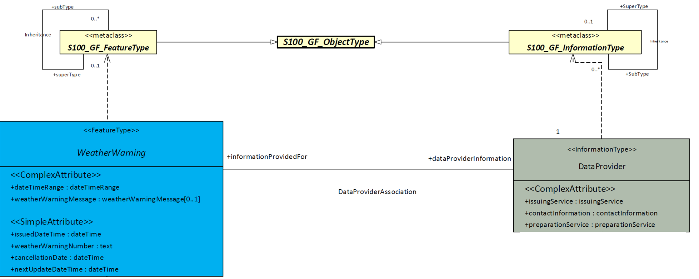

**Figure 1 -** S-412 realisation of the S-100 GFM

The complete application schema is expressed in UML and is provided in Annex A.

The data model consists of seven classes, where six are feature types and one is an information type. The feature types included are WeatherWarning, ThunderstormWarning, WindWarning, IceAccretionWarning, SignificantWaveHeightWarning, and RestrictedVisibilityWarning. These feature types are derived from the S-100_GF_FeatureType metaclass. Feature and information type descriptions can be found in Annex A.

S-412 conforms to the General Feature Model (GFM) from S-100 Part 3. This document describes the Application Schema expressed in the UML diagram. This document contains only an overview of the S-412 application schema. The S-412 Application Schema types are realised in the Feature Catalogue. The Feature Catalogue is included as a separate Annex (Annex D), and provides a full specification of all types including feature and information types, their attributes, allowed values, and the relationships between types in the data product.

The following conventions are used in the UML diagrams depicting the application schema:

* Standard UML conventions for classes, associations, inheritance, roles, and multiplicities apply. These conventions are described in Part 1 of S-100.
* Italic font for a class name indicates an Abstract Class.
* Abstract Feature Classes are depicted with a blue background.
* Ordinary (non-abstract) feature classes are depicted with a green background.
* Information type classes are depicted with a grey background. There are no abstract information type classes in S-412.
* Association Classes are depicted with a white background.
* Complex attributes are depicted with a salmon background.
* Simple attributes use a purple background.
* Enumeration lists are depicted with a yellow background. The numeric code corresponding to each listed value is shown to its right following an ‘=’ sign.
* Codelists are depicted with an orange background.
* No significance is attached to the colour of associations. (Complex diagrams may use different colours to distinguish associations that cross one another.)
* Where the association role or name is not explicitly shown, the default rules for the roles and names apply:
  + The role name is ‘the<CLASSNAME>’ where <CLASSNAME> is the name of the class to which that association end is linked.
  + The association name is ‘<CLASSNAME1>_<CLASSNAME2>’ where <CLASSNAME1> is the source and <CLASSNAME2> the target. In the case of a feature/information association, the feature is the source. For feature/feature or information/information associations without explicit names, the source/target are indicated by an arrowhead.
* Subclasses inherit the attributes and associations of their superclasses at all levels, unless such inheritance is explicitly overridden in the subclass.

## Feature Catalogue

### Introduction

The S-412 Feature Catalogue describes real-world meteorological and oceanographic concepts in one or more sets of geographic data as feature types, information types, attributes, attribute values, associations and roles. These are bound together in the Feature Catalogue, which is provided in XML format in Annex C.

Definitions of each feature type, information type, attribute, including enumerated value definitions, and associations are provided in the Data Classification and Encoding Guide (Annex A) and represent concepts that may be modelled in an S-412 data set. These definitions are drawn from a feature concept dictionary managed by the IHO through execution of the IHO Geospatial Information Registry.

### Feature Types

Feature types are the basic level of classification in the Feature Catalogue, and are used in S-412 to represent warnings of atmospheric and oceanographic phenomena.

Geographic (geo) feature types form the principal content in S-412 and are fully defined by their associated attributes and information types.

Meta features contain information about other features within a data set. Information defined by meta features override the default metadata values defined by the data set descriptive records.

Feature types may be associated to other feature types or to information types.

The realisation of a Wind Warning concept is provided in Figure 2. In this figure, Wind Warning is represented by a UML diagram. The diagram shows the Wind Warning feature’s inheritance from the abstract Weather Warning feature and its connection to various complex and simple attributes. The windWarningThreshold attribute is used to determine the category and portrayal colour of Wind Warning polygons based on wind speeds. The optional beaufortForce attribute is used to indicate more specific wind speed bins that the feature represents, based on the Beaufort Wind Scale. The dateTimeRange attribute provides the start and end times that are valid for the Wind Warning. The weatherWarningNumber attribute provides an identification number to track warnings issued with each new dataset. The optional weatherWarningMessage attribute provides a short message with added context or information about a Weather Warning.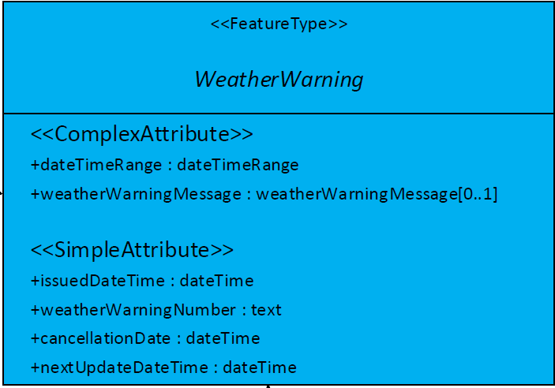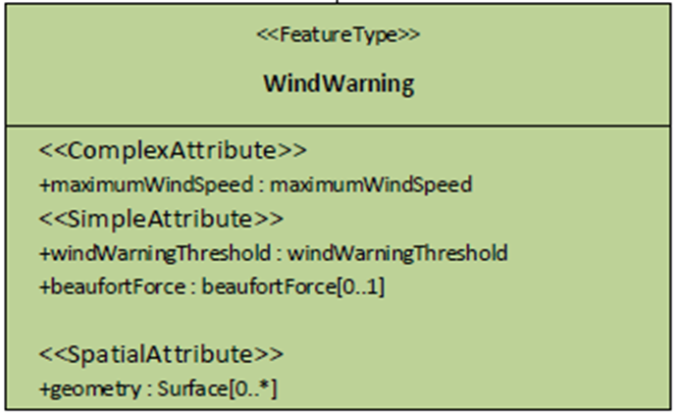

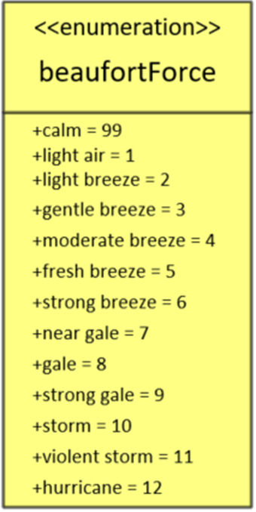



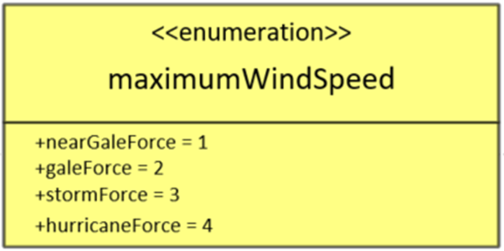

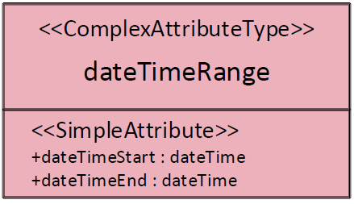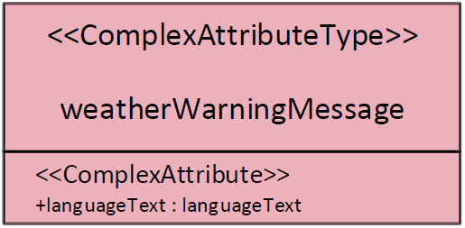

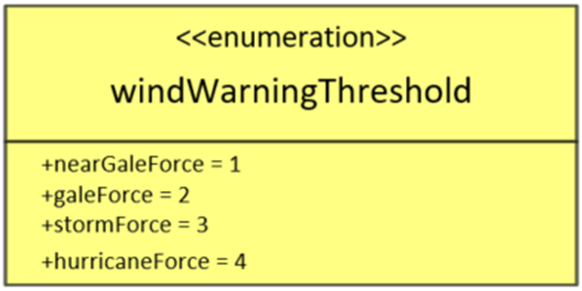

**Figure 2 -** Wind Warning feature, its attributes and associations.

### Feature Relationship

A feature relationship links instances of one feature type with instances of the same or a different feature type. There are three common types of feature relationships: Association, Aggregation, and Composition.

Associations are described in more detail in section 4.3.6. An aggregation association is a relationship between two classes, in which one of the classes plays the role of container and the other plays the role of a containee. The aggregation association shall be used when the containee objects (that represent the parts of a container object) can exist without the container object.

A composition association is a strong aggregation, where the containee object cannot exist without the container object. If a container object is deleted then all of its containee objects are deleted as well.

### Information Types

Information types define identifiable pieces of information in a dataset that can be shared between other features or information types. Information types have attributes but have no relationship to any geometry; information types may reference other information types.

Figure 3 shows the realisation of the dataProvider information type in S-412.

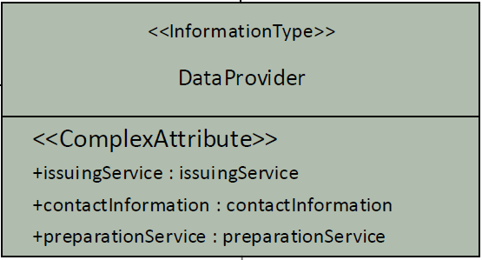



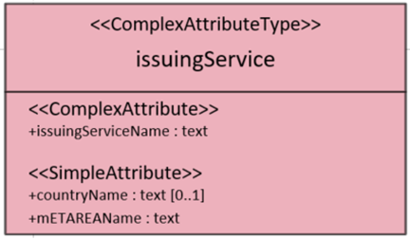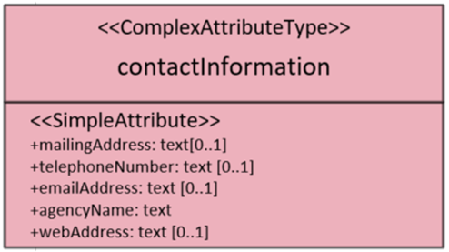

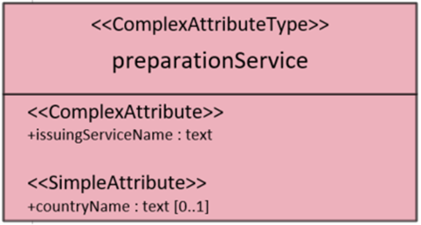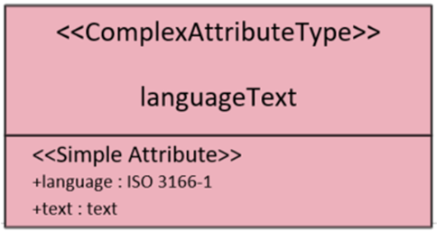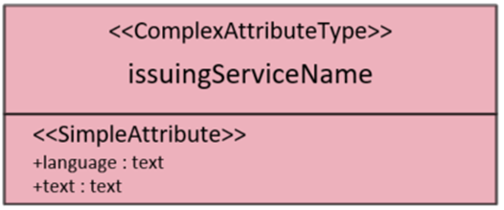

Figure 3. dataProvider and its attributes are shown. Not shown is the association between dataProvider and weatherWarning.

### Attributes

Attributes define the characteristics of a feature or information type. Attribute types can be either complex or simple. Simple attributes carry the value itself, and complex attributes are aggregations of other simple and/or complex attributes that create a hierarchical data structure to describe a feature. Unlike information types, an attribute instance belongs to one and only one feature or information type.

#### Simple Attributes

The following table lists the types of simple attributes used in S-412.

| **Type** | **Definition** |
| --- | --- |
| enumeration | List of predetermined values that can be expanded and contracted. |
| real | Floating point number. |
| integer | Numeric value with defined range, units and format. |
| text | A sequence of characters. |
| dateTime | Character encoding shall follow the format for date and time as specified in ISO 8601.  EXAMPLE: 19850412T101530 |
| boolean | True or False. |
| URN | Uniform Resource Name |

Simple attributes for the Wind Warning feature type are shown in Figure 2 and the dataProvider information type in Figure 3. Each attribute type is listed next to their camel case encoding value. Enumerated attributes are referenced by their defined data type and values are listed. Enumerated attributes, represented in UML are shown in Figure 4. The complete list of all attributes and their properties approved for use in S-412 are provided in Annex A. 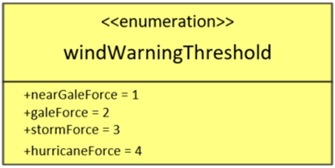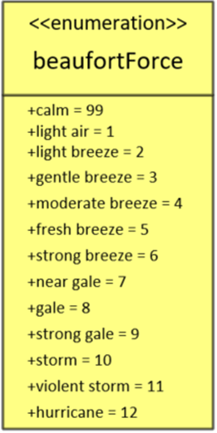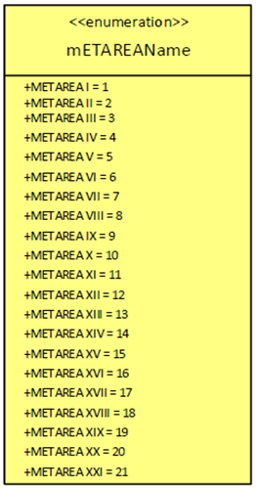

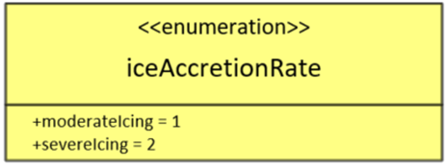

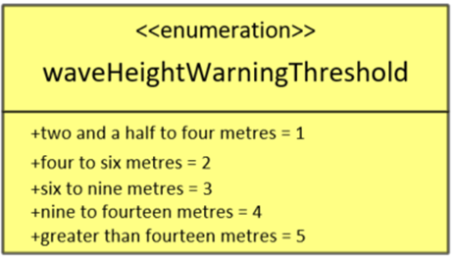

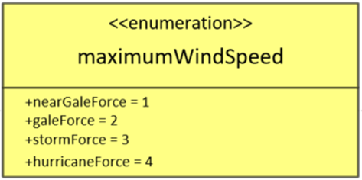

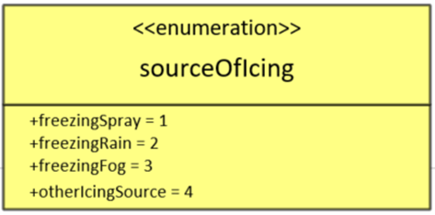

Figure 4. S-412 enumerated attributes.

#### Code Lists

Within S-100, codelist types may be used for open enumerations whose membership cannot be known at the level of the product specification, for reuse of information model fragments, or for more efficient catalogue management. Codelist types are not utilised in this version of S-412.

#### Complex Attributes

Complex attributes are aggregations of other attributes that are either simple or complex. The aggregation is defined by means of attribute bindings. Figure 5 shows the complex attribute dateTimeRange utilised by many features, including the Wind Warning feature type shown in Figure 2. This attribute is an aggregation of 2 simple dateTime attributes. A full list of complex attributes approved for use in an S-412 dataset are defined in Annex A as well as represented in UML in Figure 6.

Figure 5. The complex attribute dateTimeRange is an aggregation of 2 simple dateTime attributes (dateTimeStart and dateTimeEnd).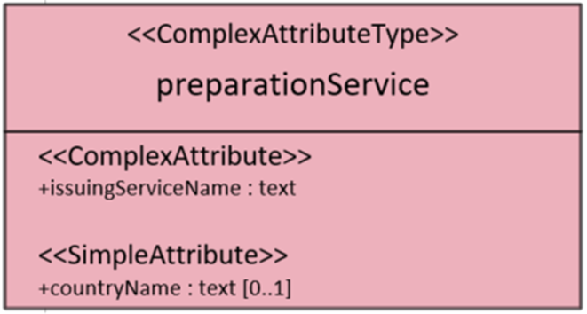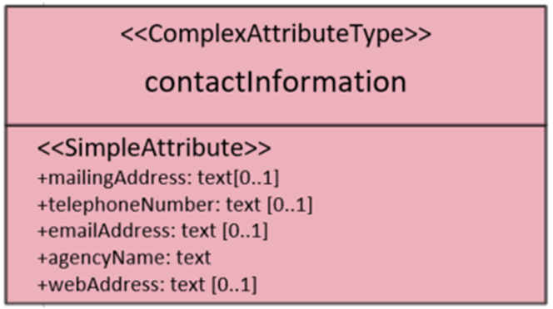

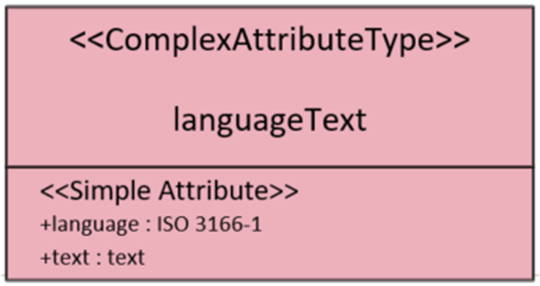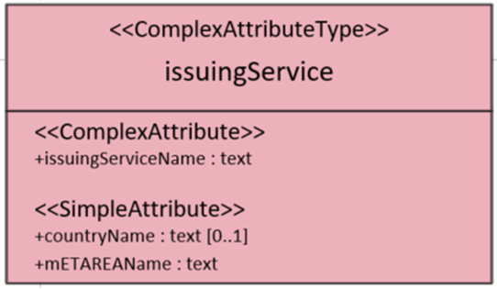

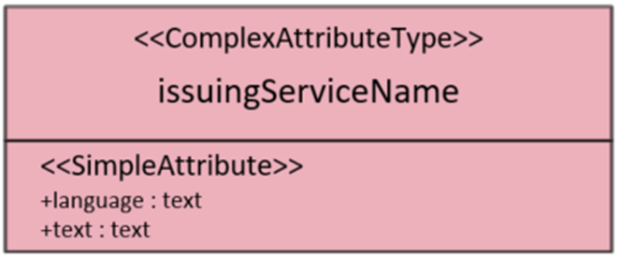

Figure 6. Complex Attributes used in S-412

### Associations

Associations are used to describe a relationship between instances of one feature or information type with instances of the same or a different feature or information type. Unless otherwise noted, associations are bi-directional in S-412. If an association is unidirectional, source and target roles are defined.

Figure 7 shows an example of the association between the WeatherWarning feature type and the DataProvider information type called DataProviderAssociation. The real world relationship between these concepts is that a weather warning has additional information about the service(s) issuing the warning.

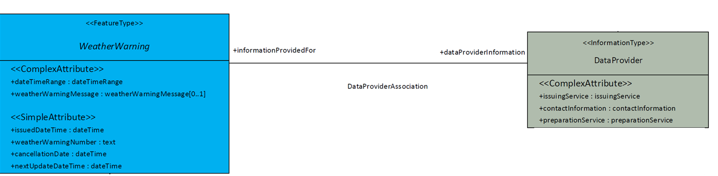

Figure 7. DataProviderAssociation between WeatherWarning and DataProvider represents the real world relationship between a weather warning and its supplemental information for where it came from. A complete list of associations and roles used in S-412 can be found in Annex A.

#### Camel Case Rules

All names in S-412 are unique in order to distinguish one from another. Further, camel case rules are applied in order to distinguish encoding values. Each class, package, type-specification and association name are concatenated and start with an uppercase letter with each subsequent word starting with a capital letter. Attribute and association role names are concatenated and start with a lower-case letter; subsequent words start with a capital letter.

Example: The Wind Warning feature type is encoded as windWarning. The Date Time Range complex attribute type is encoded as dateTimeRange.

### Multiplicity Rules

In UML, all attributes are mandatory by default. Multiplicity rules are used for attributes and association role names to provide a way of describing optional and conditional attributes. In these rules, the first number represents the minimum number of instances that may exist; the second number represents the maximum number of instances that may exist. For example, 0..* means many, optional, zero or more; 1..* means at least one.

### Inheritance

A hierarchical structure among S-412 feature types and information types exists in order to group similar concepts by definition, use cases or attribute sets. The base level of the hierarchy is commonly called the super-type and represents a generic concept. More specific concepts are the next level in the hierarchy and these are called sub-types. All sub-types inherit the properties of the super-type within the same hierarchical structure unless otherwise specified. Within S-412, inheritance creates flexibility for a data producer to utilise the appropriate feature based on their user’s needs.

In the WindWarning feature shown in Figure 2, WindWarning inherits all attributes and associations from the WeatherWarning abstract feature type.

### Spatial Quality

Spatial quality attributes are commonly carried by S-100 based product specifications in an information class called spatial qualityand describe the positional quality of an object. Because S-412 datasets are assumed to be composed of the highest quality position data available at the time of issuance, spatial quality attributes are not included in an S-412 dataset.

### Temporal Quality

There is a direct relationship between temporal quality and spatial quality with S-412 datasets. Because S-412 datasets are assumed to be composed of the highest quality position data available at the time of issuance, it is necessary to ensure the temporal quality of the dataset. Temporal quality ensures spatial quality.

Various time attributes are carried by various features to ensure the end user is aware of when the dataset is published as well as when the data is valid. Together, these attributes in the data ensure the user is aware of the temporal quality of the data.

Additionally, other time attributes are included to validate time across a dataset. For example, the issuedDateTime carried by Weather Warning is also carried by Wind Warning. If these two attributes are not the same, the dataset should not validate. Each category of Weather Warnings (Wind, Significant Wave Height, Thunderstorm, etc) also has dateTimeRange attributes showing the start and end times for the warning periods. These measures are included to ensure the most current and spatially accurate datasets are available to the end user. Further information on these validation measures can be found in Annex F. Additional time attributes such as cancellationDate and nextUpdateDateTime are discussed in section 4.4.2.

## Dataset Types

### Introduction

A dataset is a grouping of features, attributes, geometry, and metadata which comprises a specific geographic coverage. Only one type of S-412 dataset is supported: 1) GML encoding for surface geometric primitive feature collections.

### Time

S-412 datasets can represent real-world phenomena in the present or future. Because of the unique nature of atmospheric and oceanographic concepts and their geographical changes in time, a variety of time attributes are included in S-412 to ensure instances of features are attributed correctly through time. Features or information types outside of the temporal range of a dataset shall not be included in a dataset. Time shall always be provided in Coordinated Universal Time (UTC).

The dateTimeRange is a complex attribute consisting of simple attributes, dateTimeStart and dateTimeEnd, to allow certain features to define a specific temporal range. The dateTimeRange attribute is mandatory for each feature. This attribute provides data producers the flexibility to manage the temporal resolution of their datasets at the feature level and to concatenate data files in a manner which best suits their workflow and customer’s needs. In order for features to be portrayed, the user’s system must clearly indicate the dateTimeRange of a feature or a group of features if the values are the same. Instances of this attribute may be used for data validation and to ensure temporal quality.

Three other simple dateTime attributes (issuedDateTime, nextUpdateDateTime, and cancellationDate) are mandatory for each WeatherWarning and inherited into the sub-feature types. The issuedDateTime attribute provides a timestamp for when the WeatherWarning has been issued. The nextUpdateDateTime attribute provides the time information for the next expected WeatherWarning to be issued. The cancellationDate {is used to mark when a WeatherWarning is set to expire, or be cancelled}. More information about cancellationDate can be found in section {insert section}.

Every time attribute is associated with the abstract WeatherWarning feature type. These attributes are inherited by all sub-types of WeatherWarning (windWarning, significantWaveHeightWarning, iceAccretionWarning, restrictedVisibilityWarning, and thunderstormWarning). This is demonstrated in Figure 8. 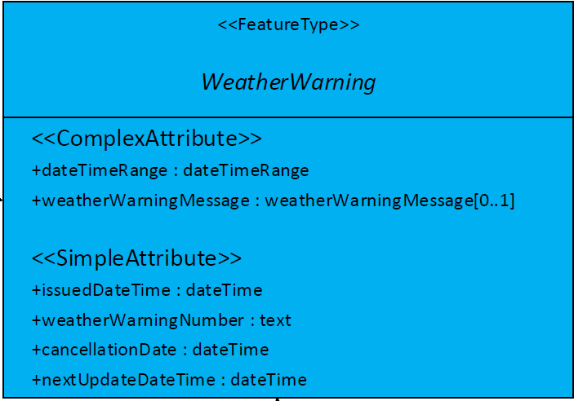



Figure 8. Time attributes associated with weatherWarning which are inherited to the sub-featuretypes.

### Multiple datasets

In order to facilitate the efficient processing and exchange of S-412 data, S-412 data files will be split by the time and date in which the file’s data is valid.

### Units of Measurement

Weather Warnings represent different types of phenomena, and thresholds categorize the severity of the warnings. Enumerated attributes are used to describe the thresholds for many weatherWarning sub-types including; windWarning, significantWaveHeightWarning, and iceAccretionWarning. For restrictedVisibility and thunderstormWarning feature types, units are determined at the feature level. More information about the units in each category are located in the definitions of each feature.

## Geometry

S-412 supports simple geometry that can be expressed in multiple configurations as described in ISO 19107:2003 clause 6.1.3. Only surface geometries represent S-412 features.

### S-100 Level 3a Geometry

The underlying geometry of an S-412 dataset is constrained to level 3a which supports 0, 1 and 2 geometric dimensional objects (points, curves and surfaces) as defined by S-100 Part 7 – Spatial Schema. This product specification uses only one type of geometry: GM_Polygon (GM_Surface).

Level 3a is described by the following constraints:

* Each curve must reference a start and end point (they may be the same).
* Curves must not self-intersect. See Figure 9
* Areas are represented by a closed loop of curves beginning and ending at a common point.
* In the case of areas with holes, all internal boundaries must be completely contained within the external boundary and the internal boundaries must not intersect each other or the external boundary. Internal boundaries may touch tangentially (i.e. at one point). See Figure 9.
* The outer boundary of a surface must be in a clockwise direction (surface to the right of the curve) and the curve orientation positive. The inner boundary of a surface must be in a counter-clockwise direction (surface to the right of the curve) and the curve orientation negative. See Figure 9.

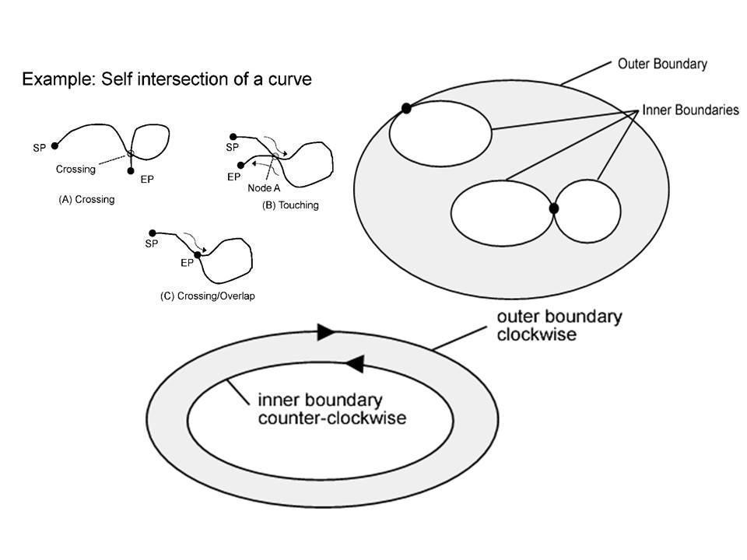

Figure 9. Level 3a geometric rules.

S-412 further constraints Level 3a with the following:

* Coincident linear geometry must be avoided when there is a dependency between features.
* Curve interpolation may be utilised to represent a variety of curve types. Curve interpolation may also be utilised for inner and outer boundaries for polygons.
* With the exception of curved interpolations, all multi-geometries must be split into single geometries.
* Curves, including interpolations, and areas should avoid crossing the 180° longitude.

Examples illustrating the variety of ways geometry may be represented in an S-412 GML data file are provided in **Annex E**.

# Coordinate Reference Systems (CRS)

## Introduction

When describing geographic information, it is common practice to separate the horizontal and vertical part of a position. This leads to 2D Coordinate Reference Systems for the horizontal positions and 1D Coordinate Reference Systems for the vertical positions.

## Horizontal Coordinate Reference System

The horizontal coordinate reference system used for this product specification is World Geodetic System 1984 (WGS 84) which is defined by the European Petroleum Survey Group (EPSG) code 4326. The longitude is stored as a negative number to represent a position west of the prime meridian. Latitude is stored as a negative number to represent a position south of the equator.

**Horizontal coordinate reference system:** EPSG:4326 (WGS84)

**Projection:** None

**Coordinate reference system registry:** [EPSG Geodetic Parameter Registry](http://www.epsg-registry.org/)

**Date type (according to ISO 19115):** 002- publication

**Responsible party:** International Association of Oil and Gas Producers (IOGP)

**URL:** http://www.iogp.org/

## Vertical Coordinate Reference System

This product specification does not apply to meteorological or oceanographic features at multiple vertical levels. All Weather Warning polygons are developed as overlays within ECS and thus are valid at the vertical datum defined by the ENC.

## Temporal Reference System

The Marine Weather Warnings Product Specification applies to meteorological features valid at specific times. The temporal reference system used is the Gregorian calendar for date and UTC for time. Time is measured by reference to Calendar dates and Clock time in accordance with ISO 19108:2002 Temporal Schema clause 5.4.4. Times must be in UTC and follow the following 25-character format: yyyymmddThhmmss.

# Data Quality

Datasets conforming to S-412 should always be created with the best available source information. Weather service providers recognized by the WMO shall be the distributor of datasets for each respective METAREA. All Marine Weather Warning information covering winds, waves, ice accretion, thunderstorms, and restricted visibility should be complete and in compliance with this Product Specification. The quality of the information can be verified with the text provided in the GMDSS.

Marine Weather Warning information is assumed to be of high quality and guaranteed by the processes employed by data providers. Quality of S-412 products depends on the combined quality of many inputs including observed, mathematically-predicted, or model-driven weather data.

S-412 products must be validated with the S-412 specific validation checks prior to release by the data producer. The data producer must review the check results and address any issues to ensure sufficient quality of the data products. The checks are a mixture of data format validation, conformance to standards, completeness and logical consistency. These validation checks are listed in Annex F.

## Completeness

Completeness is defined as the presence and absence of features, their attributes and relationships. It consists of two data quality elements:

* Commission – excess data present in a dataset;
* Omission – data absent from a dataset.

## Logical Consistency

Logical Consistency is defined as the degree of adherence to logical rules of data structure, attribution and relationships (data structure can be conceptual, logical or physical). A series of logical consistency checks for S-412 can be found in Annex F - Validation Checks. It consists of four data quality elements:

* Conceptual consistency – adherence to rules of the conceptual schema;
* Domain consistency – adherence of values to the value domains;
* Format consistency – degree to which data is stored in accordance with the physical structure of the dataset;
* Topological consistency – correctness of the explicitly encoded topological characteristics of a dataset.

## Positional Accuracy

The forecasting process is a combination of using observation data (vessel, buoy, or station reports, remotely sensed data from scatterometers, altimeters, satellite imagery, etc) alongside various weather and wave computer model datasets. These models rely on atmospheric and oceanographic physics and mathematics to predict future conditions. A forecaster uses observations and model data to analyse and predict the conditions for a geographic area. The positional accuracy of features will vary depending on the forecaster’s confidence in the correlation of these models and the conditions reported in observations.

The quality of each model will depend on the quality, timeliness, and spatial coverage of the input data (observations), as well as the mathematical and physical techniques of the model. These can be found in model technical reports.

Positional Accuracy is defined as the accuracy of the position of features within a spatial reference system. It consists of three data quality elements:

* Absolute or external accuracy – closeness of reported coordinate values to values accepted as or being true;
* Relative or internal accuracy – closeness of the relative positions of features in a dataset to their respective relative positions accepted as or being true;
* Gridded data positional accuracy – closeness of gridded data spatial position values to values accepted as or being true.

## Temporal Quality

The S-412 datasets consist of predicted and forecasted data. Because such, data quality will be highly dependent on the timestamp of each feature and the dataset development process (forecast confidence).

Traditionally, mariners have used meteorological and oceanographic products to ascertain conditions for a specific time. This can include conditions at times in the future, which may be updated as time approaches this future time. Within S-412, various time attributes exist for a forecasting agency to replicate these expectations. These attributes are for when a feature is issued, when a mariner can expect the data to be updated next, when the data is valid and the application of a time range if needed. The utilisation of these attributes will be dependent on a weather forecasting agency’s policies and will directly affect the timeliness of a dataset.

Temporal Quality is defined as the quality of the temporal attributes and the temporal relationships of features. It consists of three Data Quality Elements:

* Accuracy of a time measurement - closeness of reported time measurements to values accepted as or known to be true
* Temporal consistency – correctness of the order of events;
* Temporal validity – validity of data with respect to time.

## Thematic Accuracy

Thematic Accuracy is defined as the accuracy of quantitative attributes and the correctness of nonquantitative attributes and of the classifications of features and their relationships. It consists of three Data Quality Elements:

* Classification correctness – comparison of the classes assigned to features or their attributes to a Universe of Discourse (for example ground truth or reference data);
* Non-quantitative attribute correctness – measure of whether a non-quantitative attribute is correct or incorrect;
* Quantitative attribute accuracy – closeness of the value of a quantitative attribute to a value accepted as or known to be true.

# Data Capture and Classification

S-412 datasets may be derived from data that has been analysed by a forecaster or numerical weather prediction model output. The data is then translated into text and/or graphical format, reorganised, converted into the compliant format, and/or otherwise processed in order to be made into a usable data format.

## Data Sources

Data sources can vary across METAREAs, however, primarily comes from three sources: observations, meteorological and oceanographic forecast models, or derived products from weather models with input from a trained forecaster. Data must be produced and quality controlled by a national authority.

## Production Process

Nearly all meteorological and oceanographic information from a forecasting agency will need to be reformatted to meet the standards of this Product Specification. This means (a) populating the appropriate metadata and (b) reorganising the data in accordance with the GML and DCEG requirements of this standard.

### Metadata

### Meteorological and Oceanographic Data

Marine weather warning data must be reformatted to be compliant with this standard. S-412 warning polygons primarily contain a list of coordinate points and time attributes. Coordinate points for a warning polygon should be in decimal degrees. More information about coordinate systems is discussed in section 10.2. Additionally, time, if provided in local time, must be converted to UTC.

Descriptions of the nature of warning polygons use the following units of measurement:

* Wind is given in knots (kt)
* Wave Height is given in metres (m)
* Ice accumulation is given in centimetres per hour (cm/hr)
* Distance is given in nautical miles (nm)
* Lat and Long are given in decimal degrees up to 7 decimal numbers

# Maintenance

This clause describes the maintenance process for datasets, source, production process and how feature and portrayal catalogues are to be managed within an S-100 ECDIS.

## Dataset Maintenance and Update Frequency

Atmospheric and oceanographic conditions can change rapidly and constant revision or updating of warning datasets is essential. Datasets may be available at scheduled times or available for immediate dissemination and promulgation. Forecast data are often updated multiple times per day according to the internal policies and practices of issuing offices and the WMO. New issues of S-412 data should contain the latest information, and replace the previously issued dataset. S-412 does not currently allow for delta changes to a GML dataset. Amendments and corrections will be produced as necessary to address any errors discovered in a dataset or reflect new updates to the conditions.

## Feature and Portrayal Catalogue Management

Each new version of the Marine Weather Warnings Product Specification will include a cumulative feature and portrayal catalogue. This provides charting systems with a single set of catalogues to verify datasets against. Refer to Annex D (Feature Catalogue) and Annex G (Portrayal Catalogue).

New versions of the feature and portrayal catalogues will follow a similar approval process as the main product specification documentation. This process is described in Section 1 Product Specification Maintenance. The latest versions of these catalogues should be included in a package with the main product specification document when submitted for approval. Both new and old versions of the catalogues can be found in the IHO GI Registry.

## GML Encoding Management

All S-412 datasets are in Geography Markup Language (GML) format. Any updates or changes to features and attributes will be reflected in the GML Schema File (.XSD), which is used for validating the GML files. Refer to Annex E (GML Data Product Format (encoding)).

# Portrayal

## Introduction

S-412 portrayal is intended to contribute to the safe operation of an S-100 based system by:

* Ensuring base and supplementary levels of display for S-412 data; standards of symbols, colours and their standardised assignment to features; scale limitations of data presentation;
* Ensuring the display is clear and unambiguous,
* Establishing an accepted pattern presentation that becomes familiar to mariners and so can be recognized instantly without confusion.
* Utilising the S-100 portrayal model to ensure interoperability.

S-412 portrayal is covered by the portrayal model as defined in S-100. This model reflects how the portrayal catalogue is defined for use in systems. The portrayal catalogue defines symbology and the portrayal rules for each feature attribute combination contained in the feature catalogue.

< < Statement about the types of data allowed in GML format (points, lines, polygons) > >

## Polygon Portrayals

< < Under development – will include information about polygon features with examples of their portrayal, to include initiating portrayal rules, day/night/dusk colour palettes, orientation > >

## Temporal Rules

< < Temporal rules > >

## Transparency Rules

< < Transparency rules > >

## Intraoperability

< < Intraoperability statements, including transparency and symbol hierarchy > >

## Interoperability

< < Interoperability statements > >

## Portrayal catalogue

< < Under development – once completed, XML will be provided > >

The portrayal catalogue contains the mechanisms for the system to portray information found in S-412 datasets. The portrayal catalogue contains the following types of mechanisms and structures:

* Product Input Schema
* Set of portrayal rules
* Set of drawing instructions
* Set of symbols, line styles and colours

The portrayal catalogue model is defined in S-100 Part 9. The S-412 Portrayal catalogue is provided in Annex G and will be available in an XML document which conforms to the S-100 XML Portrayal catalogue Schema. It is structured as follows:

Root ---- (contains the catalogue named “**portrayal_catalogue.xml”**)

|

|-- Pixmaps (contains XML files describing pixmaps)

|

|-- ColorProfiles (contains XML files with colour profiles and CSS2 style sheets)

|

|-- Symbols (contains SVG files with symbols)

|

|-- LineStyles (contains XML files with line styles)

|

|-- AreaFills (contains XML files area fills)

|

|-- Fonts (contains TrueType font files)

|

|-- Rules (contains XSLT files with templates)

### Lua vs XSLT Portrayal

< < Under development > >

# Data Product Format (Encoding)

## Introduction

This clause specifies the encoding for Marine Weather Warning datasets. The principal encoding is the Open Geospatial Consortium (OGC), Geography Markup Language (GML) format as profiled by the S-100 GML schema in Part 10b of S-100. See Annex E – Data Product format (encoding) for a complete description and examples of the data records, fields and subfields defined in GML encoding.

The XML Schema for the S-412 GML application schema is available at the GI Registry (http://registry.iho.int). Feature instances must validate against the schema and conform to all other requirements specified in this data product specification including all constraints not captured in the XML Schema document.

## Encoding of Latitude and Longitude

### GML Latitude and Longitude

In S-412 GML files, latitude and longitude must be encoded in decimal degrees, e.g. for a:

*multiple point feature:*   
<gml:posList>24.700001 9.95 24.48 15.23 26.629999 22.02</gml:posList>

As modern GIS clients will likely be “axis-aware”, the order of the latitude/longitude pairs matters and should be latitude first, longitude second (YX), as in the examples above. To indicate the WGS84 horizontal coordinate reference system for the YX latitude/longitude pairs, in the GML file use:

srsName=”urn:ogc:def:crs:epsg::4326”

Also, the order of latitude-longitude pairs matters in a multiple point feature. For a curve feature, this order shall be listed in a west to east (W->E) order, as in westernmost point first and easternmost point last, or increasingly positive longitude values (see multiple point feature example above). For a surface feature, this order shall be listed in a clockwise order.Numeric Attribute Encoding

Floating point or integer attribute values must not be padded by non-significant zeros.

## Text Attribute Values

Character strings must be encoded using the character set defined in ISO 10646-1, in Unicode Transformation Format-8 (UTF-8). A BOM (byte order mark) must not be used.

## Temporal Attribute Encoding

Times must be in UTC and follow the following 25-character format: yyyymmddThhmmss (ISO 8601).

## Mandatory Attribute Values

There are five reasons why attribute values may be considered mandatory:

* They determine whether a feature is in the display base,
* Certain features make no logical sense without specific attributes,
* Some attributes are necessary to determine which symbol is to be displayed,
* Certain attributes are used to verify data quality,
* Some attributes are required for safety of navigation.

All mandatory attributes are identified in the Feature catalogue and summarised in the Data Classification and Encoding Guides provided in Annex A.

## Missing or Unknown Attribute Values

Missing or unknown values are not permitted in S-412. Mandatory attributes must contain meaningful data.

## Encoding Datasets Across 180° Longitude

Datasets must not cross the 180° meridian of longitude.

## Structure of Dataset Files

< < A description of the order of data objects in each dataset > >

## Object Identifiers

< < MRN guidance is being developed by the S-100 WG. Once completed, this section will contain guidance for completing an MRN similar to urn:mrn:WMO:S412. > >

< < Additional guidance needed about the use of gml:id for objects and geometries. > >

## Data Scale

< < Data may be scale independent. This will be determined during testing. > >

## Message Filtering Along Routes

< < Statement regarding systems ability to filter information along a route by date, time, and conditions > >

# Data Product Delivery

## Introduction

This section specifies the encoding and delivery mechanisms for an S-412 Marine Weather Warnings Overlay product from a data provider to the end user. Data which conforms to this product specification must be delivered by means of an exchange set.

The method of transfer will be primarily web-based, including ftp or direct push/pull dissemination methods. Due to the cost of transmitting data via the Internet, every effort should be made to limit exchange set file sizes below 10 MB before compression and updating frequency. Compressed files should use the Zip compression scheme.

Updated data files typically means issuing or reissuing a new forecast or issuing new warnings, including emergency messages that impact the safety of life at sea. Together, these may occur several times per day. Due to the information containing potentially lifesaving information, ECS’ to include ECDIS, should check for new data continuously.

## Exchange Set

The S-100 Exchange Set is a container that combines all the elements needed for the exchange of S-100 data. S-412 datasets are grouped into exchange sets. Each exchange set consists of one or more datasets with an associated XML metadata file and a single Exchange catalogue XML file containing the product list and the discovery metadata. It may also include one or more support files.

Static or auxiliary files, such as the feature and portrayal catalogues, SVG files, and additional supporting XML files for alarms and indications, and for interoperability should not be included in these exchange sets unless these files have been updated.

**Units of Delivery:**  Exchange Set

**Transfer Size:**  10 MB compressed

**Medium Name:**  Digital data delivery

### Exchange Set Naming

The name of the exchange set must contain the character string ‘S412’ to identify the data as containing the correct information. It must have the following structure, with S412 indicating the dataset, XXXX the metarea, and CC the 2-letter country code:

S412_XXXX_CC_FileInformation_ExchangeSet

Example: S412_XII_US_11052018NorthAtlanticForecast_ExchangeSet

It is recommended to compress the exchange set folder using zip:

S412_XII_US_11052018NorthAtlanticForecast_ExchangeSet.zip

## Exchange catalogue

< < Will include figure showing Exchange Set/Exchange catalogue/Dataset/Support file formats > >

Each exchange set has a single exchange catalogue which contains the discovery metadata for each dataset and references to any support files. The exchange catalogue acts as the table of contents for the exchange set. The catalogue file of the exchange set must be named S412ed1.CAT; no other file in the exchange set may have the same name.

## Mandatory Elements

The following are required elements within an exchange set:

* Marine Weather Warning datasets – GML encoding of features/attributes and their associated geometry and metadata.
* Exchange catalogue – the XML encoded representation of exchange set catalogue features [discovery metadata].

## Optional Elements

* Supplementary files – These are contained within the exchange set as files and the mapping from the name included within the dataset and the physical location on the media is defined within the Exchange catalogue. An example of a supplementary file could be an image.
* S-412 Feature catalogue – If it is necessary to deliver the latest feature catalogue to the end user it may be done using the S-412 exchange set mechanism for datasets.
* S-412 Portrayal catalogue - If it is necessary to deliver the latest portrayal catalogue to the end user it may be done using the S-412 exchange set mechanism for datasets.

## Dataset

### Datasets

One type of dataset file may be produced and contained within an exchange set:

* *New dataset:* Each new edition of a data set must follow the format defined in 11.6.2 and replace a previously loaded dataset within an ECS. If multiple files exist on a charting system, the system shall have the capacity to verify the most recent file is loaded and visualised for the end user.
* *Update dataset:* In some situations an update dataset will be required. This may occur if issuing an entirely new dataset is not appropriate. The GML update format should be whole-object replacements with an updated issuedDateTime attribution. If a significant number of objects or portions of the dataset needs updating, a dataset should follow the guidelines of a new dataset.
* *Re-issue:* In the event that a dataset must be reissued, it will be re-issued following the guidelines of a new dataset.

### Dataset Size

< < Exact data size restrictions and recommendations will be determined during testing > >

Datasets may be as large as necessary, provided that the entire exchange set before compression does not exceed 10MB.

### Dataset File Naming

< < This information is provided as a placeholder for now. OEM input is needed before a determination can be made. > >

New datasets will be named according to the following convention:

S412CCXXXXXXXXXX###.gml

S-412 indicates which product specification a dataset is compliant with, CC represents the data producer’s country code, XXXXXXXXXX is a unique file name defined by the data producer with a maximum character limitation of 30 characters, ### is an identifier that represents either a new dataset (000), a re-issued dataset (999) or an updated dataset (001-998).

### New Datasets and Cancellations

< < This section defines the sequencing of Marine Weather Warnings datasets for New Editions. > >

## Support Files

Data set support files offer supplementary information that can be included in an S-412 exchange set.

| **File Types** | **Extensions** | **Comment** |
| --- | --- | --- |
|  | XML | Additional Language Information |

### Support File Naming

< < This information is provided as a placeholder for now. OEM input is needed before a determination can be made. > >

Support file names are subject to the same naming rules as dataset file names (clause 11.6.3), except that the extension is determined by the support file format.

All support files must have unique universal file identifiers. The file identifier of support information should not be used to describe the physical content of the file. The support file metadata that accompanies the file will inform the user of the name and purpose of the file.

Supporting files will be named according to the following convention:

S412CCXXXXXXXXXX.TTT

S-412 indicates which product specification data the file supports, CC is 2-letter country code of the data producer, XXXXXXXXXX is a unique file name defined by the data producer with a maximum character limitation of 10 characters, and TTT is the type of file (file extension,i.e.: XML).

11.7.1.1 Names of language packs

If a language pack created by a data Producer for the S-412 Feature Catalogue is included, it must have the standard 7-character “412CCCC” prefix and the same base name as the standard IHO-issued Feature Catalogue with the 3-letter ISO 639-2/T language code suffixed. The language codes must be exactly those in the S-100 codelist for languages (S100_MD_LanguageCode, which can be found in the S-100 Schema distribution). The file extension must be “.XML”.

NOTE: A language pack issued by the IHO for the IHO Feature Catalogue will use the IHO Producer Code

### Support File Management

When a support file is created or issued it must carry a timestamp that indicates when it was issued and for when it is valid. These values are contained in the Support File Metadata as defined in clause 12.1.2 and must not change while the file is still current.

The type of support file is indicated in the “purpose” field of the discovery metadata. Support files carrying the “deletion” flag may be removed from the ECDIS. When a feature pointing to a text, picture or application file is deleted or updated so that it no longer references the file, the ECDIS software must check to see whether any other feature referenced the same file, before that file is deleted.

Support files should be stored in a separate folder within the exchange set. Each support file must be used only once in an exchange set.

## **Data** I**ntegrity**

### Weather Overlay Data Integrity Measures

There is a need for a mechanism within the S-412 data to ensure it has not changed during transmission/delivery. The mechanism chosen for this assurance is a Digital Signature as defined by S-100 Parts 15 and 17. File integrity checks are based on the Digital Signature Algorithm (DSA) as defined in the Federal Information Processing Standard FIPS 186-4. All files in the exchange set shall be digitally signed.

### Producer Identity and Authentication

A producing agency will need a certified identity, verifiable by the IHO. S-100 Part 15 describes how to define a public/private keypair specific to the producer and how a data producer or distributor is able to have their identity (as embodied in the public / private keypair) certified by the IHO acting as the data protection scheme administrator.

### Digital Signatures and Metadata

In addition to the metadata included for each dataset file and its digital signature, an exchange set must also provide a public key for every dataset data producer included within the exchange set. The public key is termed “public” because its existence is not kept confidential. Each producer’s public key is included in a “publicKeys” field within the exchange set. These keys are referred to by the digital signature.

Authentication is done in two stages:

1. Verifying that the public key information included in the exchange set validates correctly against the IHO’s root level certificate

2. Verifying that the exchange set S-412 data has not changed and the file based digital signatures are valid against the producer’s public key. The root certificate certifying IHO’s identity should be held externally on the implementing system and is not part of the dataset metadata.

### Data Encryption

Dataset files may or may not be encrypted. If encrypted, the encryption method defined in S-100 Part 15 must be applied. then it must be provided only by the mechanisms provided in IHO S-100 Part 15.

## Data Loading and Unloading

S-412 datasets are typically intended to be overlays to S-101 ENC and displayed with S-101 ENC data in the background. Systems that support the display of S-412 datasets should provide the user with simple functions to turn the display of S-412 datasets on and off.

Optionally, S-412 datasets can be viewed as overlays to a combination of S-101 ENC and S-102 (Bathymetric Surface) datasets, with S-413 (Marine Weather and Wave Conditions) and S-414 (Marine Weather Observations) datasets incorporated where applicable. The same requirements to allow the user to easily toggle the S-412 dataset on/off persist.

# Metadata

## Introduction

This clause defines the mandatory and optional metadata needed for Marine Weather Warnings Datasets and exchange sets.

For information exchange, there are several categories of metadata required: metadata about the overall exchange catalogue, metadata about each of the datasets contained in the catalogue, and metadata about the support files that make up the package.

The metadata may be repeated in a national language by including an optional and additional instance of the dataset discovery metadata per language other than the mandatory English language instance. If metadata in additional languages to English is provided, each support file will also need to be described in that language and referenced from the appropriate language metadata. English metadata should not reference metadata in another language and vice versa.

The overall structure of metadata in S-412 exchange sets is the same as in S-100, and is depicted in Figure 10. Metadata in exchange sets consists of discovery metadata for the datasets and support files in the exchange set (classes S100_DatasetDiscoveryMetadata and S100_SupportFileDiscoveryMetadata), metadata in ISO 19115-1 format for datasets, and metadata about any feature, portrayal, or interoperability catalogues which are in the exchange set (S100_catalogueMetadata).

The discovery metadata classes have numerous attributes which enable important information about the datasets and accompanying support files to be examined without the need to process the data, for example decrypt, decompress, load, etc. Other catalogues such as feature and portrayal catalogues may be included in the exchange set in support of the datasets.

More detailed information for the classes is depicted in Figure 11 and details about the metadata classes are provided in the tables in clauses 12.1.1 – 12.1.9. The S-100 classes not defined in these clauses may be found in S-100 Part 4A Appendix 4a-D.

The discovery metadata classes have numerous attributes which enable important information about the datasets and accompanying support files to be examined without the need to process the data, e.g. decrypt, decompress, load etc. Other catalogues can be included in the exchange set in support of the datasets such as feature and portrayal catalogues. The attribute “purpose” of the support file metadata provides a mechanism to update support files.

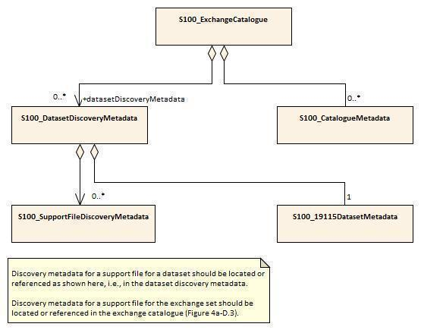

**Figure 10**

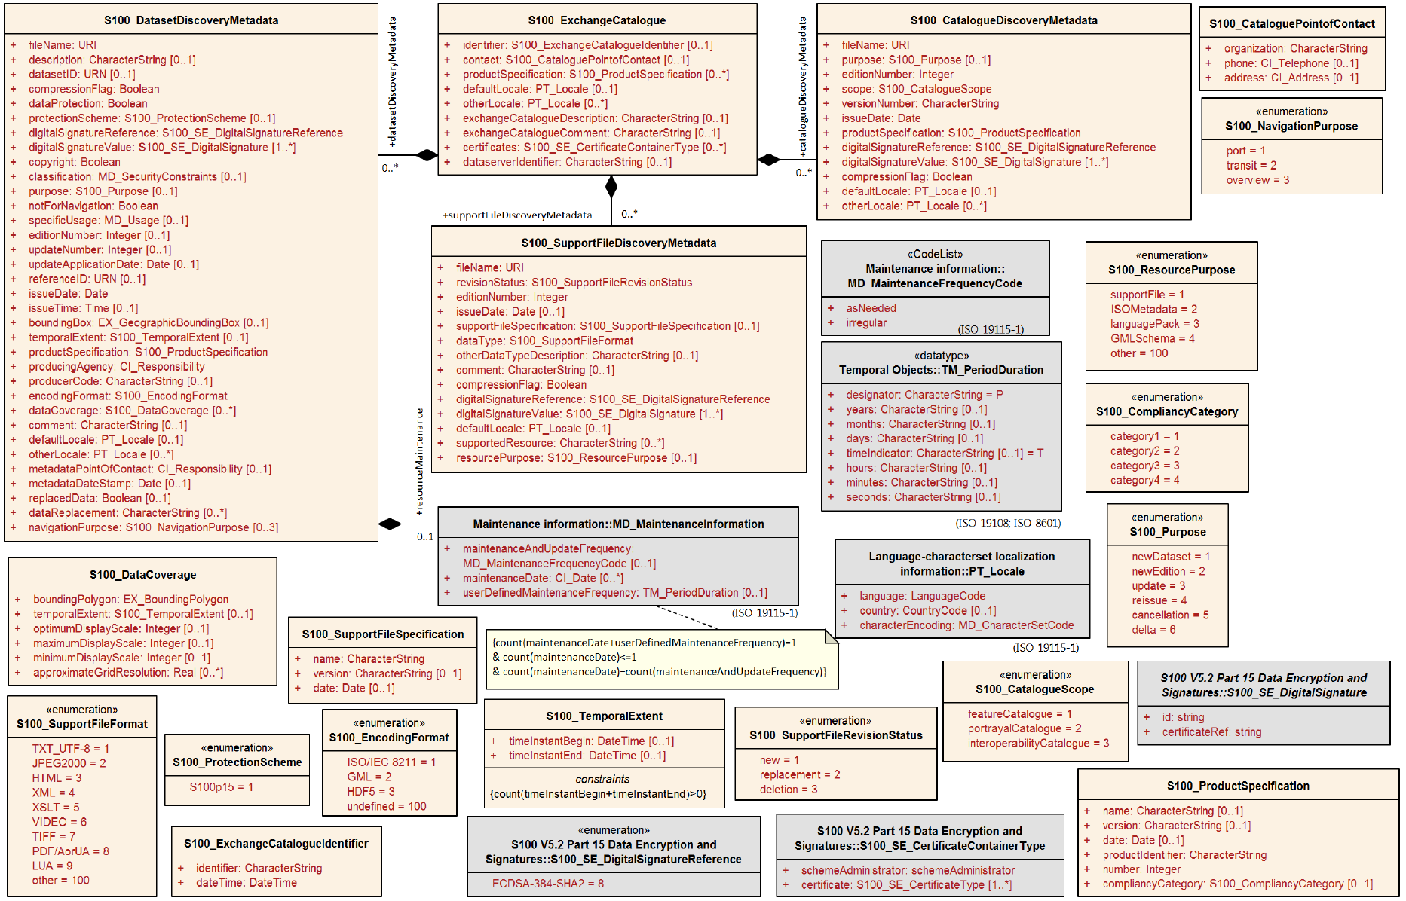

**Figure 11**

NOTE 1: Types with CI_, EX_, and MD_ prefixes are from packages defined in ISO 19115-1 and 19115-3 and adapted by S-100. Types with S100_ prefix are from packages defined in S-100.

NOTE 2: When a dataset is terminated, the purpose metadata field is set to 3 (terminated), and the editionNumber metadata field is set to 0. All inapplicable but mandatory metadata fields must be nilled.

## Metadata for Datasets

S-412 uses the following tables as detailed in S-100 Part 17, Clause 17-4.5, without modification:

* S100_ExchangeCatalogue
* S100_ExchangeCatalogueIdentifier
* S100_CataloguePointofContact
* S100_DatasetDiscoveryMetadata
* S100_NavigationPurpose
* S100_DataCoverage
* S100_Purpose
* S100_TemporalExtent
* S100_EncodingFormat
* S100_ProductSpecifictation
* S100_CompliancyCategory
* S100_ProtectionScheme
* S100_SupportFileDiscoveryMetadata
* S100_SupportFileFormat
* S100_SupportFileRevisionStatus
* S100_SupportFileSpecification
* S100_ResourcePurpose
* S100_CatalogueDiscoveryMetadata
* S100_CatalogueScope
* MD_MaintenanceFrequencyCode
* CI_DataTypeCode
* PT_Locale

The S-124 metadata description is a subset of the metadata described in S-100 Part 17, which is a profile of the ISO 19115 standard. The S-124 metadata model restricts the S-100 metadata model to its core elements; S100_ExchangeCatalogue, S100_DatasetDiscoveryMetadata, S100_CatalogueDiscoveryMetadata and S100_SupportFileDiscoveryMetadata. Moreover, the S100_DatasetDiscoveryMetadata is further restricted to remove attributes that are not relevant to a navigational warning service.

### S100_DatasetDiscoveryMetadata

Dataset discovery metadata for datasets is described in this table.

| **Role** | **Name** | **Description** | **Multi** | **Type** | **Remarks** |
| --- | --- | --- | --- | --- | --- |
| Class | S100_DataSetDiscoveryMetadata | Metadata about the individual datasets in the Exchange Catalogue | - | - | The following S-100 attributes are not used: verticalDatum, soundingDatum, optimumDisplayScale, minimumDisplayScale. |
| Attribute | fileName | Dataset file name | 1 | URI | Dataset file name (see 11.6.2) |
| Attribute | description | Short description giving the area ot location covered by the dataset | 0..1 | CharacterString | Short description of the area covered by dataset, e.g., area, harbour, or port name, between two named locations etc. |
| Attribute | datasetID | Dataset ID expressed as a Maritime Resource Name | 0..1 | URN | The URN must be a MRN |
| Attribute | compressionFlag | Indicates if the resource is compressed | 1 | Boolean | TRUE: Encrypted; indicates a compressed dataset  FALSE: Unencrypted; indicates an uncompressed dataset |
| Attribute | dataProtection | Indicates if the resource is compressed | 1 | Boolean | TRUE: Encrypted; indicates a compressed dataset  FALSE: Unencrypted; indicates an uncompressed dataset |
| Attribute | protectionScheme | Specification of method used for data protection | 0..1 | S-100_ProtectionScheme | See figure 11 and S-100 Appendix 4a -D |
| Attribute | digitalSignatureReference | Specifies the algorithm used to compute digitalSignatureValue | 1 | S100_DigitalSignatureReference (See Part 15) | “copyright” for copyrighted datasets, omitted otherwise  Old Doc: Specifies the algorithm used to compute digitalSignatureValue.  See Figure 11 and S-100 Appendix 4a-D |
| Attribute | digitalSignatureValue | Valve derived from the digital signature | 1..* | S100_SE_DigitalSignatureReference (See Part 15) | The value resulting from application of digitalSignatureReference  Implemented as the digital signature format specified in Part 15 |
| Attribute | copyright | Indicates if the dataset is copyrighted | 1 | Boolean | True indicates the resource is copyrighted  False indicates that the source is not copyrighted  Old Doc: “copyright” for copyrighted datasets, omitted otherwise |
| Attribute | classification | Indicates the security classification of the dataset | 0..1 | Class  MD_SecurityConstraints>MD_ClassificationCode (codelist)  ISO 19115-1 | 1. unclassified  2. restricted  3. confidential  4. secret  5. top secret  6. sensitive but unclassified  7. for official use only  8. protected  9. limited distribution |
| Attribute | purpose | The purpose for which the dataset has been chosen | 0..1  OD: 1 | S100_purpose | 1. New dataset 2. New edition |
| Attribute | notForNavigation | Indicates the dataset is not intended to be used for navigation | 1 | Boolean | True indicates the dataset is not intended to be used for navigation  False indicates the dataset is intended to be used for navigation |
| Attribute | specificUsage | The use for which the is intended | 0..1  OD:1 | MD_USAGE>specificUsage  (character string)  MD_USAGE>userContactInfo  (CI_Responsibility) | brief description of the resource and/or resource series usage |
| Attribute | editionNumber | The edition number of the dataset | 0..1  OD:1 | Integer | When a dataset is initially created, the edition number “1” is assigned to it. The edition number is increased by one with each new edition. |
| Attribute | updateNumber | Update number assigned to the dataset and increased by one for each subsequent update | 0..1 | Integer | Update sequence number, must match the update file name.  Mandatory only for updating datasets. |
| Attribute | updateApplicationDate | This data is only used for the base cell files (that is new data set, re-issued, and new edition). not update cell files. All updates dated on or before this date must have been applied by the producer | 0..1 | Date | Date of update.  Mandatory only for updating datasets. |
| Attribute | issueDate | Date in which the data was made available by the Data Producer | 0..1  OD:1 | Date | Date on which the dataset was generated. |
| Attribute | issueTime | Time of day at which the data was made available by the Data Producer | 0..1 | Time | Encoded only if time of issue is significant. |
| Attribute | boundingBox | The extent of the dataset limits | 0..1 | EX_GeographicBounding Box | - |
| Attribute | temporalExtent | Specification of the temporal extent of the dataset | 0..1 | S100_TemporalExtent | The temporal extent is encoded as the date/time of the earliest and latest data records (in coverage datasets) or date/time ranges (in vector datasets)  If there is more than one feature in a dataset, the earliest and latest time values of records in all features are used, which means the earliest and latest values may be from different features  If date/time information for a feature is not encoded in the dataset, it is treated for the purposes of this attribute as extended indefinitely in the appropriate direction on the time axis, limited by the issue date/time or the cancellation or supersession of the dataset  This attribute is encoded if and only if at least one of the start and end of the temporal extent is known |
| Attribute | productSpecification | The product specification used to make this dataset | 1 | S100_ProductSpecification | See Notes below this table for constraints on values. |
| Attribute | producingAgency | Agency responsible for producing the data | 1 | CI_Responsibility>CI_Organization or  CI_Responsibility>CI_Individual | Party responsible for generating the dataset.  See S-100 Part 4a Tables 4a-2 and 4a-3. |
| Attribute | producerCode | The official IHO Producer Code from S-62 | 0..1 | CharacterString |  |
| Attribute | dataCoverage | Provides information about data coverages within the dataset | 0..* | S100_DataCoverage | See Figure 11 and S-100 Appendix 4a-D. A new or new-edition S-412 dataset must have at least one coverage. |
| Attribute | comment | Any additional information | 0..1 | CharacterString | Any additional Information |
| Attribute | defaultLocale | Default language and character set used in the dataset | 0..1  OD:1 | PT_Locale | See Figure 11 and S-100 Appendix 4a-D. |
| Attribute | otherLocale | Other languages and character sets used in the dataset | 0..* | PT_Locale | See Figure 11 and S-100 Appendix 4a-D. |
| Attribute | metadataPointOfContact | Point of contact for metadata | 0..1  OD:1 | CI_Responsibility>CI_Individual or  CI_Responsibility>CI_Organization | See S-100 Part 4a Tables 4a-2 and 4a-3. |
| Attribute | metadataDateStamp | Date stamp for metadata | 0..1  OD:1 | Date | Metadata creation date, which may or may not be the dataset creation date |
| Attribute | replacedData | Indicates if a cancelled dataset is replaced by another data file(s) | 0..1 | Boolean | See Note |
| Attribute | dataReplacement | Dataset name | 0..* | CharacterString | A dataset may be replaced by 1 or more datasets  See Note |
| Attribute | navigationPurpose | Classification of intended navigation purpose (for Catalogue indexing purposes) | 0..3 | S100_NavigationPurpose | If Product Specification is intended for creation of navigational products this attribute should be mandatory |
| Role | resourceMaintenance | Information about the frequency of resource updates, and the scope of those updates | 0..1 | MD_MaintenanceInformation | S-100 restricts the multiplicity to 0..1 and adds specific restrictions on the ISO 19115 structure and content. See clause MD_MaintenaceInformation later in this Part  Format: PnYnMnDTnHnMnS (XML built-in type for ISO 8601 duration). See clause 17-4.9 |
|  | -- | 0..* |  | Aggregation S100_SupportFileDiscoveryMetadata | One for each support file linked to this dataset and present in the exchange set. |

**NOTES:**

**Attribute *productSpecification*: The values of sub-attributes *name* and *version* must correspond to this version of the S-412 product specification. The value of the sub-attribute *number* must be the number assigned to this version of the S-412 product specification in the GI registry.**

### S100_DataCoverage

| **Role** | **Name** | **Description** | **Multi** | **Type** | **Remarks** |
| --- | --- | --- | --- | --- | --- |
| Class | S100_DataCoverage | A spatial extent where data is provided; and the display scale information for the provided data. | - | - | This field is used by user systems as part of the data loading and unloading algorithms and is strongly encouraged that Product Specifications mandate the use of one or more of the displayScale provided as part of S100_DataCoverage  Old Doc: The S-100 attributes optimumDisplayScale and minimumDisplayScale are not used in S-412. |
| Attribute | boundingPolygon | A polygon which defines the actual data limit | 1  OD: 1..* | EX_BoundingPolygon | The extent of the dataset limits |
| Attribute | temporalExtent | Specification of the temporal extent of the coverage | 0..1 | Integer | A polygon which defines the actual data limit |
| Attribute | optimumDisplayScale | The scale with which the data is optimally displayed | 0..1 | Integer | Example: A scale of 1:25000 is encoded as 25000 |
| Attribute | maximumDisplayScale | The maximum scale with which the data is optimally displayed. | 0..*  OD: 1 | Integer | Mandatory in S-412.  Value 700000 means that S-412 data cannot be viewed at a larger scale than 1:700001 (i.e. at 1:700000 it is turned off). |
| Attribute | minimumDisplayScale | The minimum scale with which the data is displayed | 0..1 | Integer |  |
| Attribute | approximateGridResolution | The resolution of gridded or georeferenced data (in metres) | 0..* | Real | A single value may be provided when all axes have a common resolution  For multiple value provision, use axis order as specified in dataset  May be approximate for ungeorectified data  For example, for 5 metre resolution, the value 5 must be encoded  (See Note 2) |

NOTE 1: boundingPolygon is restricted to a single GML Polygon with one exterior and 0 or more interiors expressed as Linear Rings using SRS EPSG:4326. The exterior and optional interiors shall be composed of a closed sequence of >=4 coordinate positions expressed individually or as a list (posList). The GML polygon shall have a valid GML identifier.

NOTE 2: approximateGridResolution: If the grid cell size varies over the extent of the grid, an approximated value based on model parameters or production metadata should be used.

NOTE 1: If there are multiple grid or TIN features in the dataset, each feature should have a separate dataCoverage attribute in dataset discovery metadata, except that the coverages for intersecting or adjacent features with the same grid resolution may be combined at producer discretion.

NOTE 2: Bounding polygons for grid features should be the same as the spatial extent of the grid.

NOTE 3: Bounding polygons for TIN features may either be the union of all triangles defined in the TIN, or the bounding box covering all the vertexes of the TIN.

NOTE 4: Bounding polygons for multipoint features (DCF 1 and 8) may be one or more reasonably minimized polygons or bounding boxes that together cover all data points.

NOTE 5: A boundingPolygon is restricted to a single GML Polygon with one exterior and 0 or more interiors expressed as Linear Rings using SRS EPSG:4326. The exterior and optional interiors shall be composed of a closed sequence of >=4 coordinate positions expressed individually or as a list (posList). The GML polygon shall have a valid GML identifier

NOTE 6: For approximateGridResolution, if the grid cell size varies over the extent of the grid, an approximated value based on model parameters or production metadata should be used.

### S100_EncodingFormat

| **Role Name** | **Name** | **Description** | **Code** | **Remarks** |
| --- | --- | --- | --- | --- |
| Enumeration | S100_DataFormat | The encoding format | - | The S-100 values *ISO/IEC 8211*, *HDF5* and *undefined* are not allowed in S-412 datasets. |
| Value | ISO/IEC 8211 | The ISO 8211 data format as defined in Part 10a | 1 | - |
| Value | GML | The GML data format as defined in Part 10b | 2 | Only GML is allowed in S-412 |
| Value | HDF5 | The HDF5 data format as defined in Part 10c | 3 | - |
| Value | undefined | The encoding is defined in the Product Specification | 100 | Use of Product Specification specific encoding means the data product and Product Specification is not intended for an IHO S-100 compliant system |

## Support File Metadata

Support file metadata is intended to describe information about a data resource. It facilitates the management and exploitation of data and is an important requirement for understanding the characteristics of a data resource. If it is required to generate support file metadata in another language than English, an additional instance per language is created. The language is defined in the language attribute of the PT_Locale class.

### S100_SupportFileDiscoveryMetadata

| **Role** | **Name** | **Description** | **Multi** | **Type** | **Remarks** |
| --- | --- | --- | --- | --- | --- |
| Class | S100_SupportFileDiscoveryMetadata | Metadata about the individual support files in the Exchange Catalogue | - | URI | The S-100 attribute otherDataTypedescription is not used in S-412. |
| Attribute | fileName | Name of the support file | 1 | CharacterString |  |
| Attribute | revisonSatus | The purpose for which the support file has been issued | 1 | S100_SupportFileRevisionStatus | For example new, replacement, etc |
| Attribute | editionNumber | The Edition of the support file | 1 | Integer | When a dataset is initially created, the edition number 1 is assigned to it. The edition number is increased by 1 at each new edition. Edition number remains the same for a re-issue |
| Attribute | issueDate | Date on which the data was made available by the Data Producer | 0..1  OD:! | Date |  |
| Attribute | supportFileSpecification | The specification used to create this file | 0..1  OD:1 | S100_SupportFileSpecification | See Figure 11 and S-100 Appendix 4a-D. |
| Attribute | dataType | The format of the support file | 1 | S100_SupportFileFormat | The only values allowed for support files referenced in datasets is TIFF.  Values XML, XSLT, and LUA are reserved for portrayal catalogue files.  The value ASCII can only be used for portrayal catalogue files that do not fit into one of the other types. |
| Attirbute | otherDataDescription | Support file format other than those listed | 0..1 | CharacterString |  |
| Attribute | comment | Optional comment | 0..1 | CharacterString |  |
| Attribute | compressionFlag | Indicates if the resource is compressed | 1 | Boolean | True indicates a compressed resource  False indicates an uncompressed resource |
| Attibure | digitalSignatureReference | Specifies the algorithm used to compute digitalSignatureValue | 1  OD: 0..1 | S100_DigitalSignatureReference  (See Part 15) | Specifies the algorithm used to compute digitalSignatureValue.  See Figure 11 and S-100 Appendix 4a-D. |
| Attribute | digitalSignatureValue | Value derived from the digital signature | 1..*  OD: 0..1 | S100_DigitalSignatureValue  (See Part 15) | The value resulting from application of digitalSignatureReference.  Implemented as the digital signature format specified in S-100 Part 15. |
| Attribute | defaultLocale | Default language and character set used in the support file | 0..1  OD:1 | PT_Locale | See Figure 11 and S-100 Appendix 4a-D. |
| Attribute | supportedResource | Identifier of the resource supported by this support file | 0..* | CharacterString | Conventions for identifiers are detailed in S-100 Part 15. S-100 allows file URI, digital signature or cryptographic has checksums to be used |
| Attribute | resourcePurpose | The purpose of the supporting resource | 0..* | S100_SupportFilePurpose | new, replacement, or deletion.  Values "replacement” and “deletion” are allowed only in update datasets. |
| Attribute | otherLocale | 0..* |  | PT_Locale | See Figure 11 and S-100 Appendix 4a-D. |
| Attribute | fileLocation | 1 |  | CharacterString | Path relative to the root directory of the exchange set. The location of the file after the exchange set is unpacked into directory <EXCH_ROOT> will be  <EXCH_ROOT>/<filePath>/<filename> |

### S100_SupportFileFormat

| **Role Name** | **Name** | **Description** | **Code** | **Remarks** |
| --- | --- | --- | --- | --- |
| Enumeration | S100_SupportFileFormat | The format used in the support file | - | The S-100 values *JPEG2000*, *VIDEO*, *PDF/A or UA*, and *other* are not allowed in S-412. |
| Value | TCT_UTF-8 | UTF-8 text excluding control codes | 1 | - |
| Value | JPEG2000 | JPEG2000 format | 2 | ISO 15444 |
| Value | HTML | Hypertext Markup Language | 3 |  |
| Value | XML | Extensible Markup Language | 4 | Only for portrayal catalogue files. |
| Value | XSLT | Extensible Stylesheet Language Transformation | 5 | Only for portrayal catalogue files. |
| Value | VIDEO | Representation of moving images in unspecified format | 6 |  |
| Value | TIFF | Tagged Image File Format | 7 |  |
| VAlue | PDF/AorUA | Portable Document File | 8 | ISO 19005, ISO 32000  Product Specification developers should take careful considerations in using PDF as a support file format. It is recommended that PDF never be used in products that will be used on a navigation system as it may impair night vision  Must be PDF/A or UA |
| Value | LUA | Lua programing language | 9 | Only for portrayal catalogue files. |
| Value | Other | Other format | 100 |  |
| Value | ASCII |  | - | Only for portrayal catalogue files of types not falling into one of the other categories. |

### 

## Exchange catalogue File Metadata

### S100_ExchangeCatalogue

All S-412 Exchange catalogue files must contain at least the mandatory metadata elements in this table.

| **Role** | **Name** | **Description** | **Multi** | **Type** | **Remarks** |
| --- | --- | --- | --- | --- | --- |
| Class | S100_Exchangecatalogue | An Exchange Catalogue contains the discovery metadata about the exchange datasets and support files | * - | - | - |
| Attribute | identifier | Uniquely | 0..1  OD:1 | S100_ExchangeCatalogueIdentifier | See Notes below this table. |
| Attribute | contact | Details about the issue of the datasets contained in the Exchange Catalogue | 0..1  OD:1 | S100_CataloguePointOfContact | No special constraints on the S-100 class. |
| Attribute | productSpecification | Details av=bout the Product Specifications used for the datasets contained in the Exchange Catalogue | 0..*  OD:0..1 | S100_ProductSpecification | Conditional on all the datasets using the same product specification. See note below this table for constraints on values. |
| Attribute | defaultLocale | Default language and character set used for all metadata record in this Exchange Catalogue | 0..1 | PT_Locale | Default is English and UTF-8 |
| Attribute | otherLocale | Other languages and character sets used for the localized metadata records in this Exchange Catalogue | 0..* | PT_Locale | Required if any localized entries are present in the Exchange Catalogue |
| Attribute | exchangeCatalogueDescription | Description of what the Exchange Catalogue contains | 0..1  OD:1 | CharacterString |  |
| Attribute | exchangeCatalogueComment | Any additional information | 0..1 | CharacterString | Old Doc: Any additional Information |
| Attribute | certificates | Signed public key certificates referred to by digital signatures in the Exchange Set | 0..* | S100_SE_ CertficateContainerType | Content defined in S-100 PArt 15. All certificates used, except the SA root certificate (installed separately by the implementing system) shall be included |
| Attribute | dataServerIdentifier | Identifies the data server for the permit | 0..1 | CharacterString |  |
| Role | datasetDiscoveryMetadata | Exchange Catalogues may include or reference discovery metadata for the datasets in the Exchange Set | 0..* | Aggregation S100_DatasetDiscoveryMetadata | Metadata for the Feature, Portrayal and Interoperability Catalogues, if any  Old Doc: blank |
| Role | catalogueDiscoveryMetadata | Metadata for Catalogue | 0..* | Aggregation  S100_DatasetDiscoveryMetadata |  |
| Role | supportFileDiscoveryMetadata | Exchange Catalogues may include or reference discovery metadata for the support files in the Exchange Set | 0..* | Aggregation S100_SupportFileDiscoveryMetadata | Old Doc: blank |
|  | compressionFlag | 0..1 |  | Boolean | TRUE: compressed  FALSE: not compressed  If compressed, the method must be that specified in S-100 Part 15. |
| Attribute | metadataLanguage | 1 | English | CharacterString | All datasets conforming to this PS must use the English language. A catalogue in English must be provided. Discovery metadata elements within catalogues have their own locale attributes and may be repeated in languages other than English. |
|  | exchangecatalogueName | 1 | catalogue.XML | CharacterString | catalogue filename |
|  | sourceMedia | 0..1 |  | CharacterString |  |
|  | replacedData | 0..1 |  | Boolean |  |
|  | dataReplacement | 0..1 |  | CharacterString |  |
|  |  |  |  |  |  |
|  | -- | 0..* |  | Aggregation S100_catalogueMetadata | Metadata for the feature, portrayal, and interoperability catalogues, if any |

**NOTES:**

1. **Attribute *productSpecification*: Class** S100_ProductSpecification **is depicted in Figure 11 and defined in S-100 Appendix 4a-D. The values of sub-attributes *name* and *version* must correspond to this version of the S-412 product specification. (Clause 4.2). The value of the sub-attribute *number* must be the number assigned to this version of the S-412 product specification in the GI registry.**
2. **Attribute *catalogueIdentifier*: Class** S100_catalogueIdentifier **is depicted in Figure 11 and defined in S-100 Appendix 4a-D. The value of sub-attribute *S100_catalogueIdentifier>identifier* must be chosen so that a one-to-one mapping from exchange set name to catalogue identifier is recommended. This assumes a system for assigning unique names to exchange sets – as opposed to datasets – is developed, either by the producer or in this specification. Note that an exchange set may contain multiple datasets.**

## Language

The exchange language must be English. Other languages may be used as a supplementary option. National geographic names can be left in their original national language in the international attributes, or transliterated or transcribed and used in the international attributes.

Character strings must be encoded using the character set defined in ISO 10646-1, in Unicode Transformation Format-8 (UTF-8). A BOM (byte order mark) must not be used.